

CAPSTONE PROJECT REPORT
Report 3 – Software Requirement Specification

– Hanoi, Jun 2026 –
Table of Contents
I. Record of Changes 3
II. Software Requirement Specification 4
1. Overall Requirements 4
1.1 Context Diagram 4
1.2 Main Workflows 5
1.3 User Requirements 5
1.4 System Functionalities 7
1.5 Entity Relationship Diagram 7
2. Use Case Specifications 8
2.1 <<Feature Name1>> 8
2.2 Xyz Feature 10
3. Functional Requirements 11
3.1 Feature Name1 11
3.2 User Authentication 11
3.3 System Administration 12
4. Non-Functional Requirements 13
3.1 External Interfaces 13
3.2 Quality Attributes 13
5. Requirement Appendix 14
5.1 Business Rules 14
5.2 System Messages 14
5.3 Other Requirements… 15

I. Record of Changes
Date | A*  M, D | In charge | Change Description
20/07/2026 | M | HungPV | Section II.1.3.2 Use Cases: replaced UC 12 (View AGV request acceptance status) and UC 13 (Search AGV) with Activate / Deactivate AGV and Handle AGV disconnection mid-task; restricted UC 4, 5, 12 and 14 to the Admin actor.
20/07/2026 | M | HungPV | Section II.1.4.2 Screen Authorization: removed Operator access to AGV List and AGV Detail to match the Admin-only API guard.
20/07/2026 | M | HungPV | Section II.1.5 Entity Descriptions: the AGV entity stores codes and serial numbers, not MAC addresses.
20/07/2026 | M | HungPV | Section II.2.1 Use Case Specifications: rewrote the specifications for UC 12 and UC 13; corrected UC 1, 2, 4, 5 and 14 - the AGV is identified by a unique code (no MAC address field exists) and carries no status attribute.
20/07/2026 | A | HungPV | Section II.2.1 Use Case Specifications: added a Business Rules reference row to each FE-01 use case specification.
20/07/2026 | M | HungPV | Section II.3.1 Functional Requirements: AGV screen field tables now use Code instead of MAC Address.
20/07/2026 | M | HungPV | Section II.5.1 Business Rules: corrected BR-01 (the charging threshold must be lower than the operational threshold); marked BR-03 as not implemented in this release; extended BR-06 (an ignored AGV remains a spatial obstacle in fleet routing).
20/07/2026 | M | HungPV | Section II.5.2 System Messages: corrected MSG-14 (duplicate AGV code) and MSG-15 (the charging threshold must be lower).
20/07/2026 | M | HungPV | Sections II.1.4.2, II.2.1 and II.3.1: replaced the non-existent OFFLINE vehicle state with the states the kernel actually reports (IDLE, EXECUTING, CHARGING, ERROR, UNAVAILABLE, UNKNOWN); corrected the UC 3 precondition to PICKING_UP / DELIVERING.
20/07/2026 | M | HungPV | Editorial: removed leftover working notes from the headings of sections 2.2.26, 2.3 and 5 and from the Screen Authorization table; deleted two empty placeholder headings.
20/07/2026 | D | HungPV | Section II.1.5 Entity Descriptions: removed AGV Live Status, AGV Status History and AGV Error History - no such tables exist; live vehicle state is held in memory and its history in vehicle_state_transitions.
20/07/2026 | D | HungPV | Sections II.1.3.2, II.2.2 and II.5.2: dropped map topology editing (point, path and block management). Removed section 2.2.26 View Topology Block Details and messages MSG-21 and MSG-22, which referenced use cases that no longer exist. Topology is edited in the openTCS Model Editor; WES manages maps and operational locations only.
20/07/2026 | A | HungPV | Sections II.1.3.2 and II.2.2: added UC 37 View operational location details, UC 38 Set kernel operating mode and UC 39 Synchronise operational locations with the plant model - all three are implemented but were undocumented. Added the specification for UC 36 Remove point from location, which had no specification.
20/07/2026 | M | HungPV | Sections II.1.3.2 and II.2.2: UC 32 now covers only the name and colour of a location; the location type is fixed at creation and member points are handled by UC 35 and UC 36. Section II.1.5: the Operation Map entity no longer claims a DRAFT/ACTIVE/ARCHIVED status - that column was dropped from the schema.
20/07/2026 | A | HungPV | Section II.5.1: added BR-11 (drop-off cascading depth-first fill), already cited by section II.1.4.3, and BR-12 (an operational location may change its members or be deleted only while no active cargo references it). Section II.1.4.3 now cites OR-07 for the debounce window instead of a business rule. BR-03 is marked as planned for a future release.
20/07/2026 | A | HungPV | Section II.2.2: added a Business Rules reference row to each Warehouse Map & Topology use case specification.
22/07/2026 | M | HungPV | Sections II.1.3.2.4, II.1.4.3 and II.5.1: aligned the transport-request lifecycle to the implemented state machine (WAITING_DISPATCH to READY_TO_ASSIGN, removed DISPATCHING, PICKUP_COMPLETED to DELIVERING, corrected the UC 47 status-filter values); changed invalid-cargo handling to fail-fast rejection with no INVALID record and removed UC 49 and UC 50; corrected the debounce window to 1.5 seconds (OR-07); added a note that transport-request monitoring is delivered through the unified Cargo view (Cargo and Transport Request are 1:1).
22/07/2026 | M | HungPV | Section II.5.1 Business Rules: implemented BR-03 (forced charging) for this release and replaced the two battery thresholds with critical (default 20%) and sufficient (default 60%); updated BR-01 and BR-02 and reversed MSG-15; added BR-13 (nearest free CHARGE slot, per-zone reserved) and BR-14 (charging preempts parking). Added the Charge Engine non-UI function (Section II.1.4.3). Relabelled UC 6 and UC 7 and their specifications (Sections II.2.1.6 and II.2.1.7) from operational/charging to critical/sufficient.
23/07/2026 | A, M | HungPV | Section II.5.1 Business Rules: rewrote BR-03 (charge lifecycle — on a critical-AGV demand the AGV yields the charge point to a parking position rather than to work; once fully charged with no demand it vacates the charge point to a parking position that is not part of a charge location) and added BR-15 (idle parking targets non-charge parking positions; charge points are reserved for charging). Section II.1.4.3 Non-UI Functions: updated the Charge Engine (#20) description to match.
*A - Added M - Modified D - Deleted

II. Software Requirement Specification

1. Overall Requirements

1.1 Context Diagram
The Smart Warehouse Execution System for AGV Coordination (SWES) acts as the central coordination layer between warehouse users, barcode scanning devices, email notification services, and the openTCS/FMS fleet execution environment. The system receives operational requests such as login credentials, cargo or transport request queries, scanned item and location codes, AGV configuration data, map and topology settings, dispatch policy configuration, and manual dispatch or cancellation actions.
SWES processes these inputs to manage transport requests, coordinate AGV task assignment, monitor vehicle and cargo status, enforce dispatch policies, and synchronize warehouse operation data with openTCS/FMS. In return, the system provides authentication results, request validation outcomes, cargo and transport request status, AGV/task progress, operational map data, exception or blocking status, configuration results, event logs, and email notification requests such as password reset or account notifications.
The context diagram below shows the main external actors and systems involved in the current release, including Admin, Operator, Barcode Scanner, Gmail Service, AGV, and openTCS/FMS. AGV communication is handled indirectly through openTCS/FMS, which receives movement and transport execution commands from SWES and returns vehicle state, kernel status, transport order events, and task execution results.
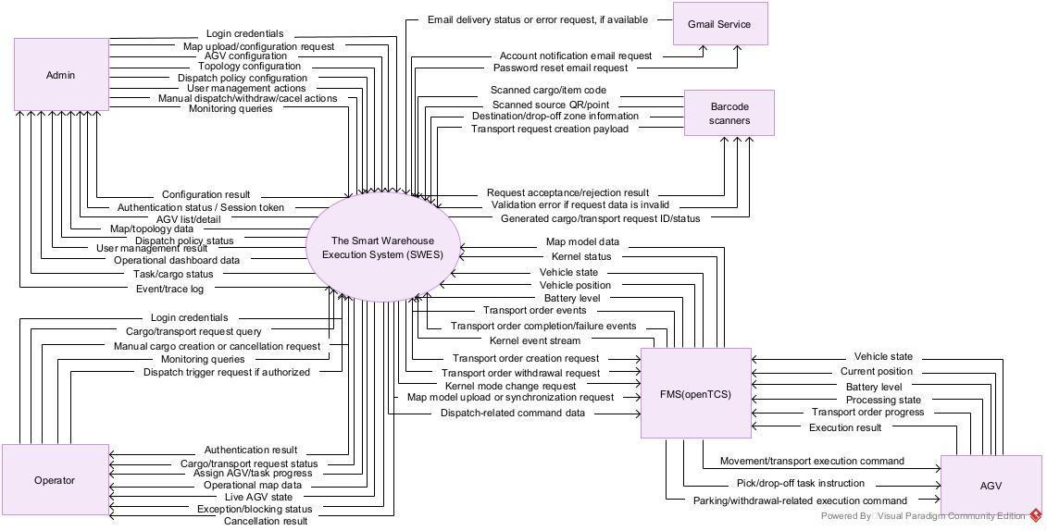

1.2 Main Workflows

1.2.1 Pickup

1.2.2 Delivery

1.2.3 Cancel & Delete

1.3 User Requirements

1.3.1 Actors
# | Actor | Description
1 | Operator | The on-site personnel. Responsible for using handheld devices to scan codes to create cargo records and trigger transport requests, tracking the status of their created orders, monitoring the execution progress of AGVs at the pickup/drop-off areas, and canceling tasks or deleting cargo entities when necessary.
2 | Admin | The system administrator. Responsible for comprehensive system configuration, including: spatial map (topology) setup, fleet configuration, dispatch policy definition, and user management. The Admin also monitors real-time operational efficiency via the Dashboard, handles congestion/deadlock alerts, manages cargo deletion (data integrity), and tracks KPI metrics.
3 | Barcode Scanner/ Handheld App | The on-site client/edge device. Acts as an external peripheral system that generates input data. It optically decodes floor QR codes and package barcodes, packages the payload, and calls the WES API to first create a Cargo entity, and subsequently initiate the lifecycle of a Transport Request.
4 | FMS (openTCS) | The middleware system managing device communication, acting as a customized version of the openTCS source code. It provides an API for connecting to the AGV hardware and continuously synchronizing telemetry states with the WES. The default Dispatching subsystem (task-to-vehicle assignment) of openTCS has been taken over by WES. FMS now receives the Transport Order with an already assigned vehicle (intendedVehicle) from WES, executes the physical routing (pathfinding), and instructs the AGV hardware to move accordingly.
5 | Gmail Service | A third-party email delivery service is responsible for transmitting authentication emails, specifically containing the OTP and the password reset link, to the end-users.
6 | AGV | A physical automated vehicle that executes warehouse transport operations. The AGV communicates with SWES indirectly through openTCS/FMS: openTCS sends execution commands to the AGV, and AGV status such as position, battery level, processing state, and transport order progress is reported back to SWES via openTCS.

1.3.2 Use Cases (UC)
ID | Use Case | Actors | Use Case Description
AGV-FM | AGV Fleet Management
1 | Create AGV | Admin | Add a new AGV to the system database.
2 | Update AGV information | Admin | Modify existing AGV details (name, model, etc.).
3 | Delete AGV | Admin | Remove an AGV record from the system.
4 | View AGV list | Admin | Display a paginated table of all registered AGVs.
5 | View AGV details | Admin | Show specific properties and current status of an AGV.
6 | Configure critical battery threshold | Admin | Set the critical battery percentage at or below which an AGV must go and charge.
7 | Configure sufficient battery threshold | Admin | Set the battery percentage at or above which a charging AGV is considered sufficiently charged to rejoin dispatch.
8 | Enable AGV to accept requests | Admin | Manually allow an AGV to receive dispatch commands.
9 | Disable AGV from accepting requests | Admin | Manually stop an AGV from receiving new dispatch commands.
10 | Ignore AGV from the system | Admin | Exclude an AGV from orchestration without deleting it.
11 | Restore ignored AGV | Admin | Re-include an ignored AGV back into orchestration.
12 | Activate / Deactivate AGV | Admin | Link or unlink an AGV to the fleet kernel so that only vehicles physically present and ready are tracked and controlled.
13 | Handle AGV disconnection mid-task | System, Admin | Detect an AGV that stops communicating while executing a task, exclude it from new assignments, and keep its last known position reserved for fleet routing.
14 | Filter AGVs by status | Admin | Filter the AGV list by kernel-reported state (IDLE, EXECUTING, CHARGING, ERROR, UNAVAILABLE, UNKNOWN) and by WES dispatch flags.
15 | View AGV operation history | Admin | Display the timeline of tasks and movements for an AGV.
16 | View AGV error history | Admin | Display the log of physical or software errors (e.g., E_STOP).
WMT | Warehouse Map & Topology
17 | Upload new operation map | Admin | Upload a new base map file (layout/grids).
18 | Replace current operation map | Admin | Overwrite the active map and remap existing topology.
31 | Create operational location | Admin | Group points to define a pickup/drop-off/charge area.
32 | Update operational location | Admin | Modify the name and colour of an operational location.
33 | Delete operational location | Admin | Remove an operational location grouping.
34 | View operational location list | Admin, Operator | Display all defined operational areas.
35 | Assign point to location | Admin | Map specific QR points to an operational location.
36 | Remove point from location | Admin | Unmap specific QR points from an operational location.
37 | View operational location details | Admin, Operator | Show the member points, position indices, type and colour of a specific operational location.
38 | Set kernel operating mode | Admin | Switch the FMS kernel between MODELLING and OPERATING so that a new plant model can be uploaded or normal dispatching can resume.
39 | Synchronise operational locations with the plant model | Admin | Re-read the active plant model and mark any operational location whose member points no longer exist, or that conflicts with another location, as stale.
TR | Transport Request
42 | Operator creates request from scanned data | Barcode Scanner, Operator | API endpoint to ingest request from scanner (QR + Barcode).
43 | Operator creates manual transport request | Admin, Operator | UI form to manually input source and destination for a task.
44 | View transport request list | Admin, Operator | Display a paginated list of all transport requests.
45 | View transport request details | Admin, Operator | Show full lifecycle info of a specific transport request.
46 | Search transport requests | Admin, Operator | Search tasks by ID, item code, or location.
47 | Filter transport requests | Admin, Operator | Filter tasks by status (Blocked, Picking Up, Delivering, Delivered, Cancelled, Failed).
48 | Cancel transport request | Admin, Operator | Abort an active or pending transport request.
51 | View AGV assigned to the request | Admin, Operator | Display which AGV is currently handling the task
52 | View transport request execution progress | Admin, Operator | Track real-time progress of the task fulfillment.
53 | View reason for unassigned request | Admin, Operator | Show why a task is stuck in the queue (e.g., no free AGV).
54 | View selected pickup point for the request | Admin, Operator | Display the exact calculated node for the pickup action.
55 | View selected drop-off point for the request | Admin, Operator | Display the exact calculated node for the drop-off action.
56 | View reason for no valid pickup/drop-off point | Admin, Operator | Explain logic failure when generating exact target nodes.
57 | Create cargo | Scanner, Operator, Admin | Register a cargo entry in the system with source point and destination location, initiating the transport request lifecycle.
58 | Delete cargo | Admin, Operator | Remove a cargo record from the system and automatically cancel any linked transport task that has not yet reached DELIVERING state.
59 | View cargo list | Admin, Operator | Display a paginated list of all cargo entries, filterable by status (Active, Delivered, Cancelled).
60 | View cargo details | Admin, Operator | Show full information of a specific cargo entry including source, destination, linked transport task, and status history.
TRD | Traffic Routing & Dispatch
61 | Configure AGV dispatch policy | Admin | Define rules for task prioritization and assignment logic.
62 | Update AGV dispatch policy | Admin | Modify existing dispatch and orchestration rules.
63 | View transport request dispatch queue | Admin | View the list of requests waiting to be orchestrated.
64 | View details of a request in dispatch queue | Admin | Examine specific orchestration parameters of a queued task.
65 | View blocked dispatch requests | Admin | Display tasks that cannot be dispatched due to logic blocks.
66 | View reason for held-back requests | Admin | Show physical/logic constraints preventing dispatch (e.g., out of order).
67 | View traffic congestion alerts | Admin, Operator | Dashboard alert indicating a traffic jam in a block/path.
68 | View deadlock risk alerts | Admin | Dashboard alert indicating potential AGV deadlocks.
69 | View projected AGV route | Admin | Visualize the planned pathing array for an AGV on the map.
70 | View system's reason for AGV selection | Admin | Display the heuristic/logic used to assign a specific AGV.
71 | Manage availability status of station/location | Admin | Toggle whether a station/location can accept new tasks.
OMD | Operational Monitoring Dashboard
72 | View overall operation dashboard | Admin, Operator | High-level overview of system health and active operations.
73 | View real-time operation map | Admin, Operator | 2D canvas displaying the layout, topology, and active grids.
74 | View AGV live preview on map | Admin, Operator | Real-time positional tracking of AGVs on the operation map.
75 | View completed requests KPI | Admin, Operator | Chart/metric showing total completed tasks over time.
76 | View average transport time KPI | Admin, Operator | Chart/metric showing average end-to-end task completion time.
77 | View AGV utilization rate KPI | Admin, Operator | Chart/metric showing the percentage of time AGVs are active.
78 | View active AGVs count KPI | Admin, Operator | Simple counter of currently online and operating AGVs.
79 | View transport request fail rate KPI | Admin, Operator | Chart/metric calculating the percentage of failed tasks.
80 | View average AGV assignment wait time KPI | Admin, Operator | Chart/metric showing average time a task waits in queue.
81 | View throughput by time frame KPI | Admin, Operator | Chart showing task completion volume segmented by hours/shifts.
82 | View list of congested areas or hotspots | Admin, Operator | Heatmap or list of layout areas with frequent slowdowns.
83 | View list of AGVs with high error frequency | Admin, Operator | Highlight specific vehicles that repeatedly fail or trigger errors.
UAM | User & Access Management
84 | System login | Admin, Operator | Authenticate user using credentials to access the system.
85 | System logout | Admin, Operator | Terminate the current active session securely.
86 | View personal info | Admin, Operator | Display the logged-in user's profile details.
87 | Update personal info (profile) | Admin, Operator | Modify user's own profile data (name, contact info, etc.).
88 | Change password | Admin, Operator | Allow user to update password after verifying the current one.
89 | Forgot/reset password reset | Admin, Operator | Request a secure password reset OTP via email
90 | Create user account | Admin | Admin creates a new system login for an operator.
91 | Update user account | Admin | Modify user details (name, email, etc.).
92 | Delete user account | Admin | Remove a user's access from the system entirely.
93 | View user list | Admin | Display a list of all registered system users.
94 | View user details | Admin | Show specific information about a user account.
95 | Lock user account | Admin | Temporarily disable a user from logging in.
96 | Unlock user account | Admin | Re-enable a previously locked user account.
97 | Assign role to user | Admin | Grant a specific role (Admin, Operator) to a user.
98 | Remove role from user | Admin | Revoke a specific role from a user account.
99 | Reset user password | Admin | Admin forces a password reset for a user account.
LOG | Event Log & Audit Trail
100 | View system events list | Admin, Operator | Display a generic, paginated list of all system logs.
101 | View system event details | Admin, Operator | Show deep metadata and payloads for a specific system event.
102 | Search system events | Admin, Operator | Search logs by keyword, ID, or timestamp.
103 | Filter system events | Admin, Operator | Filter logs by severity (Info, Warning, Error) or module.
104 | View AGV change history | Admin | Track modifications made to AGV profiles or settings.
105 | View topology change history | Admin | Track map, point, path, or block configuration changes.
106 | View dispatch configuration change history | Admin | Audit log of who changed routing or dispatch rules and when.
107 | View user action history | Admin | Track explicit actions performed by an Operator or Admin.
108 | View details of a user session | Admin | Show login times, IP, and actions within a specific session.
109 | Export system log report | Admin | Generate and download a CSV/PDF report of system logs.

1.3.2 Use Case Diagrams

1.3.2.1 UCs for User & Access Management
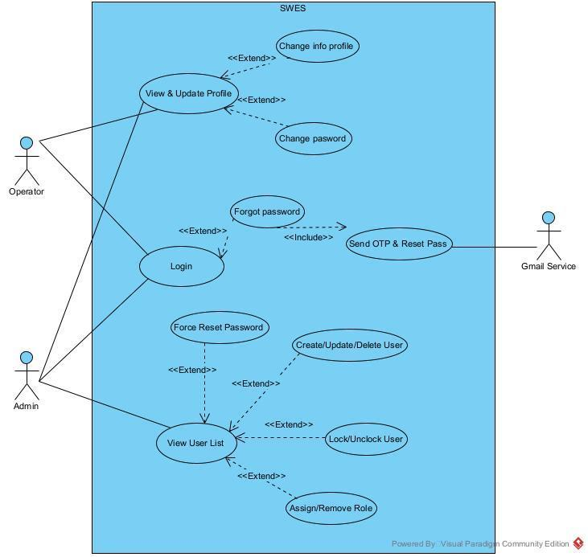

1.3.2.2 UCs for AGV Fleet Management
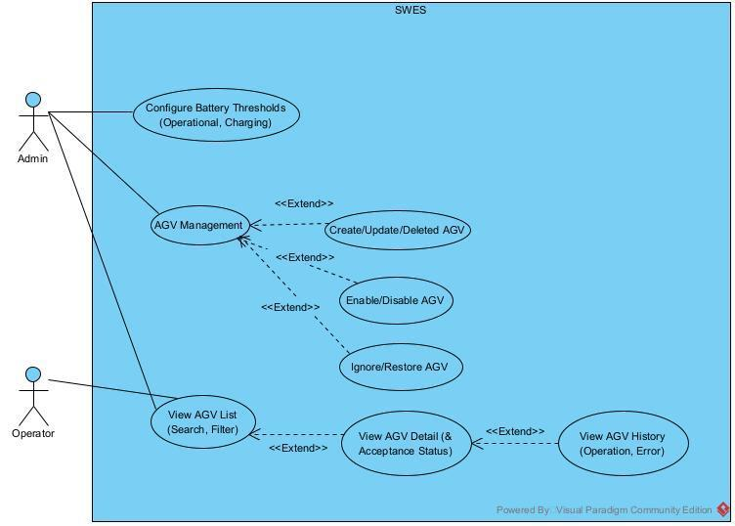

1.3.2.3 UCs for Warehouse Map & Topology

1.3.2.4 UCs for Transport Request
Note: Cargo and its Transport Request are created together as a 1:1 pair, so the Transport Request monitoring use cases in this section (list, details, search, filter, cancel, assigned vehicle, execution progress, selected pickup/drop-off point, block reason) are delivered through the unified Cargo view -- each Cargo surfaces its linked request's live status; there is no separate Transport Request management screen. Fleet-level orchestration monitoring (dispatch queue, held-back reasons) belongs to Traffic Routing & Dispatch (Section II.1.3.2.5).
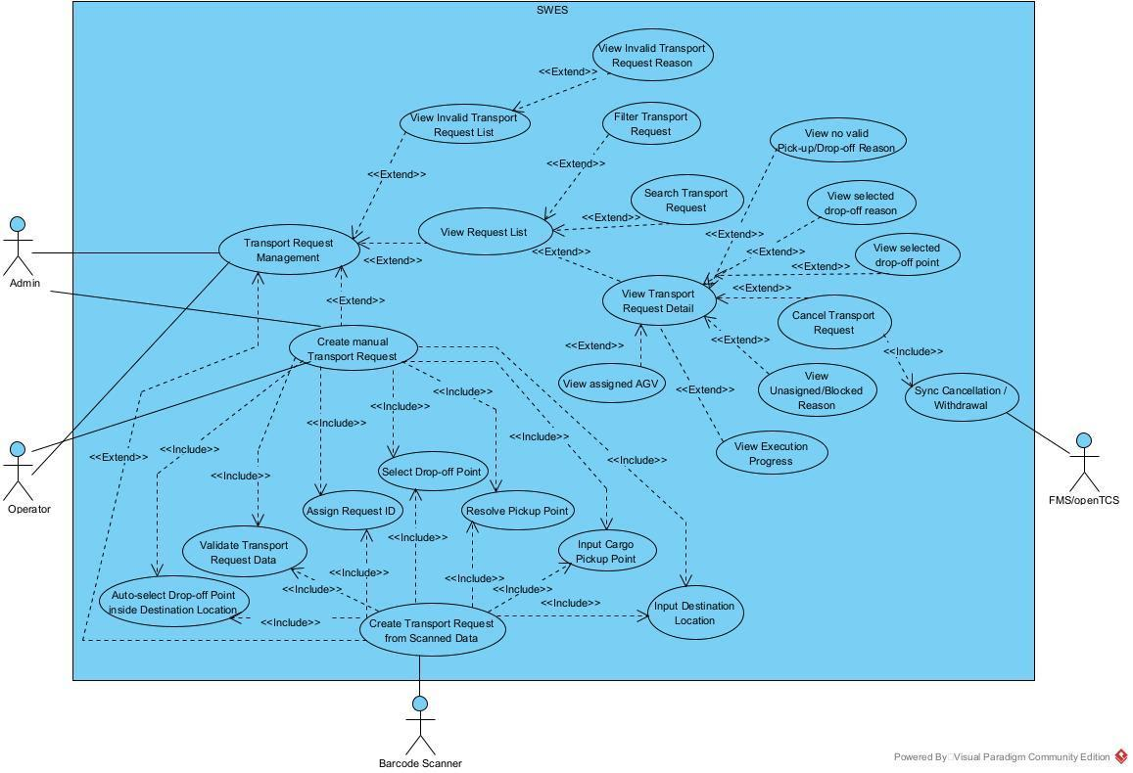

1.3.2.5 UCs for Traffic Routing & Dispatch

1.3.2.6 UCs for Operational Monitoring Dashboard
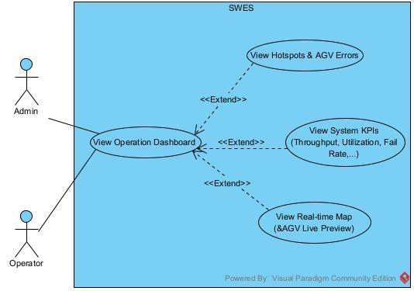

1.3.2.7 UCs for Event Log & Audit Trail
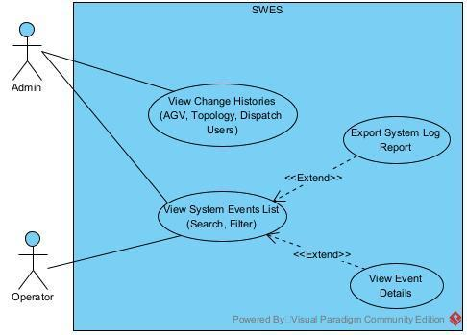

1.4 System Functionalities

1.4.1 Screens Flow

1.4.2 Screen Authorization
Screen | Operator | Admin
Login Page | X | X
Forgot Password | X | X
Reset Password | X | X
Profile | X | X
Edit Profile | X | X
Change Password | X | X
Dashboard | X | X
AGV List |  | X
Create AGV |  | X
AGV Detail |  | X
Edit AGV |  | X
Map Editor (Canvas) |  | X
Location List | X | X
Location Detail | X | X
Create Location |  | X
Live Map Full View | X | X
Request Detail | X | X
Create Request | X | X
Invalid Request List | X | X
Invalid Request Detail | X | X
Cargo List | X | X
Cargo Detail | X | X
Create Cargo | X | X
User List |  | X
User Detail |  | X
Create User |  | X
Edit User |  | X

1.4.3 Non-UI Functions
# | Feature | System Function | Description
1 | Transport Request & Cargo | Scanner Cargo Ingestion API | REST API endpoint that receives the payload from the Barcode Scanner (source QR point + destination barcode). Validates the source point and destination location against the active topology, then creates a Cargo record and a Transport Request. If validation fails, the request is rejected immediately with a reason (fail-fast); no Cargo or Transport Request is persisted.
2 | Transport Request & Cargo | Pickup Point Calculator | Applies the outer-before-inner rule (BR-10) to determine the exact pickup slot within a PICKUP location. Selects the slot with the highest position index that is not currently occupied by an executing task, ensuring AGVs always pick up from the outermost accessible position first.
3 | Transport Request & Cargo | Drop-off Point Calculator | Applies the Cascading Depth-First Fill algorithm (BR-11) to determine the optimal drop-off slot within a DROPOFF location. Prioritizes filling innermost slots first to avoid gaps between cargo, maximizing storage density and physical layout consistency.
4 | Transport Request & Cargo | Cargo Debounce Timer | After a Transport Request is created, applies a 1.5-second debounce window (OR-07) before triggering the conflict check. During this window, new requests targeting the same location are grouped together, preventing race conditions in slot assignment when multiple scans arrive in rapid succession.
5 | Transport Request & Cargo | Conflict Check Engine | After the debounce window closes, checks for slot conflicts across all pending Transport Requests. Ensures no two requests are simultaneously assigned to the same pickup or drop-off point. Conflicting requests are placed in BLOCKED state with a recorded reason.
6 | Transport Request & Cargo | Transport Order Creator | Assembles the validated Transport Request data (pickup point, drop-off point, assigned AGV) into a Transport Order object and submits it to the FMS (openTCS) via its REST API, including the intendedVehicle field so FMS does not re-assign the AGV.
7 | Transport Request & Cargo | FMS Withdrawal Caller | Calls the FMS (openTCS) API to withdraw (cancel) a Transport Order when the corresponding Transport Request is cancelled or fails after being dispatched. Ensures the FMS execution layer remains synchronized with the WES task lifecycle.
8 | Traffic Routing & Dispatch | Task Release Engine | Periodically scans the Task Pool to identify Transport Requests eligible for dispatch (status READY_TO_ASSIGN, valid pickup/drop-off points calculated, not in BLOCKED state). Releases eligible tasks into the dispatch queue for assignment processing.
9 | Traffic Routing & Dispatch | Task Assignment Engine | Implements the Hungarian Algorithm over a task×vehicle cost matrix. Base cost is the directed road-graph shortest-path distance from the vehicle to the pickup point, scaled per vehicle by a battery term (weight_battery) so a low-battery vehicle pays more for a long trip; task selection is ordered by urgency (weight_urgency). Assigns an AGV to each queued Transport Request and updates the request status to PICKING_UP.
10 | AGV Fleet Management | AGV Telemetry Sync | Periodically polls the openTCS kernel (every 2 seconds, POLL_INTERVAL_MS = 2000) to synchronize real-time AGV state (current position, battery level, operational status) into the agv_live_status table. Detects AGVs that go offline or enter error states and triggers relevant event log entries.
11 | Warehouse Map & Topology | Map Auto-Load to FMS | On system bootstrap, reads the plant model XML from the OPENTCS_MAP_PATH environment variable and pushes it to the FMS kernel via putPlantModel(). Skipped if OPENTCS_MAP_AUTO_LOAD=false or if FMS returns HTTP 409/400 (model already exists), preventing duplicate uploads on restart.
12 | Warehouse Map & Topology | Map Activation Push | When an Admin activates a new map in WES, pushes the full topology configuration (points, paths, blocks, locations) to the FMS kernel via the openTCS REST API. Ensures the FMS pathfinding layer always operates on the same topology as the WES orchestration layer.
13 | Operational Monitoring Dashboard | KPI Snapshot Generator | Periodically aggregates and persists operational Key Performance Indicators into the kpi_snapshots table, including: total completed requests, success rate, throughput (requests/hour), average transport time, average assignment wait time, active AGV count, and failure rate.
14 | Operational Monitoring Dashboard | SSE Push Service | Maintains persistent Server-Sent Events (SSE) connections with connected clients to push real-time updates without polling: live AGV positions on the map, Transport Request status changes, congestion/deadlock alerts, and system state changes. Broadcasts updates to all subscribed clients immediately upon state change.
15 | User & Access Management | Email Delivery Service | Integrates with the Gmail Service to send authentication-related emails: invitation/setup links (48-hour TTL) when an Admin creates a new user, and password reset links (30-minute TTL, single-use token) for forgot-password and Admin-initiated reset flows. Email failures are handled gracefully without blocking the primary operation.
16 | User & Access Management | Refresh Token Cleanup | Periodically removes expired and revoked refresh tokens from the database to prevent unbounded table growth. Ensures the refresh_tokens table remains lean and that stale token records do not interfere with authentication integrity checks.
17 | System | FMS Kernel Health Check | On system bootstrap, polls the FMS kernel state (up to MAX_ATTEMPTS = 30 times at 2-second intervals, totaling 60 seconds) to confirm the kernel is ready before WES begins accepting requests. Logs a warning and proceeds if the kernel does not become reachable within the timeout window.
18 | System | Audit Log Writer | Automatically records all Create, Update, and Delete operations performed by Admins on configurable system entities (AGV, Map, Block, Location, Dispatch Policy, User) into the audit_logs table. Each entry captures the actor, entity type, entity ID, action, changed fields, and timestamp.
19 | System | Event Log Writer | Records technical diagnostic events and system errors into the event_logs table, categorized by module (AGV, MAP, TRANSPORT, DISPATCH) and severity (INFO, WARNING, ERROR). Serves as the foundation for system monitoring, runtime debugging, and post-incident audit trail analysis.
20 | AGV Fleet Management | Charge Engine | Each dispatch flush, evaluates fleet battery levels: sends any AGV at or below the critical threshold — after it finishes its current task — to the nearest CHARGE location with a free slot, and holds it out of dispatch while charging. It releases the AGV once its battery reaches the sufficient threshold and there is demand: a pending request sends it to serve, while another AGV at or below critical makes it yield the slot and move to a parking position. With no demand it keeps charging; once fully charged it vacates the charge point to a parking position that is not part of a charge location, so the slot is never held idle. IGNORED AGVs are never forced to charge.

1.5 Entity Relationship Diagram
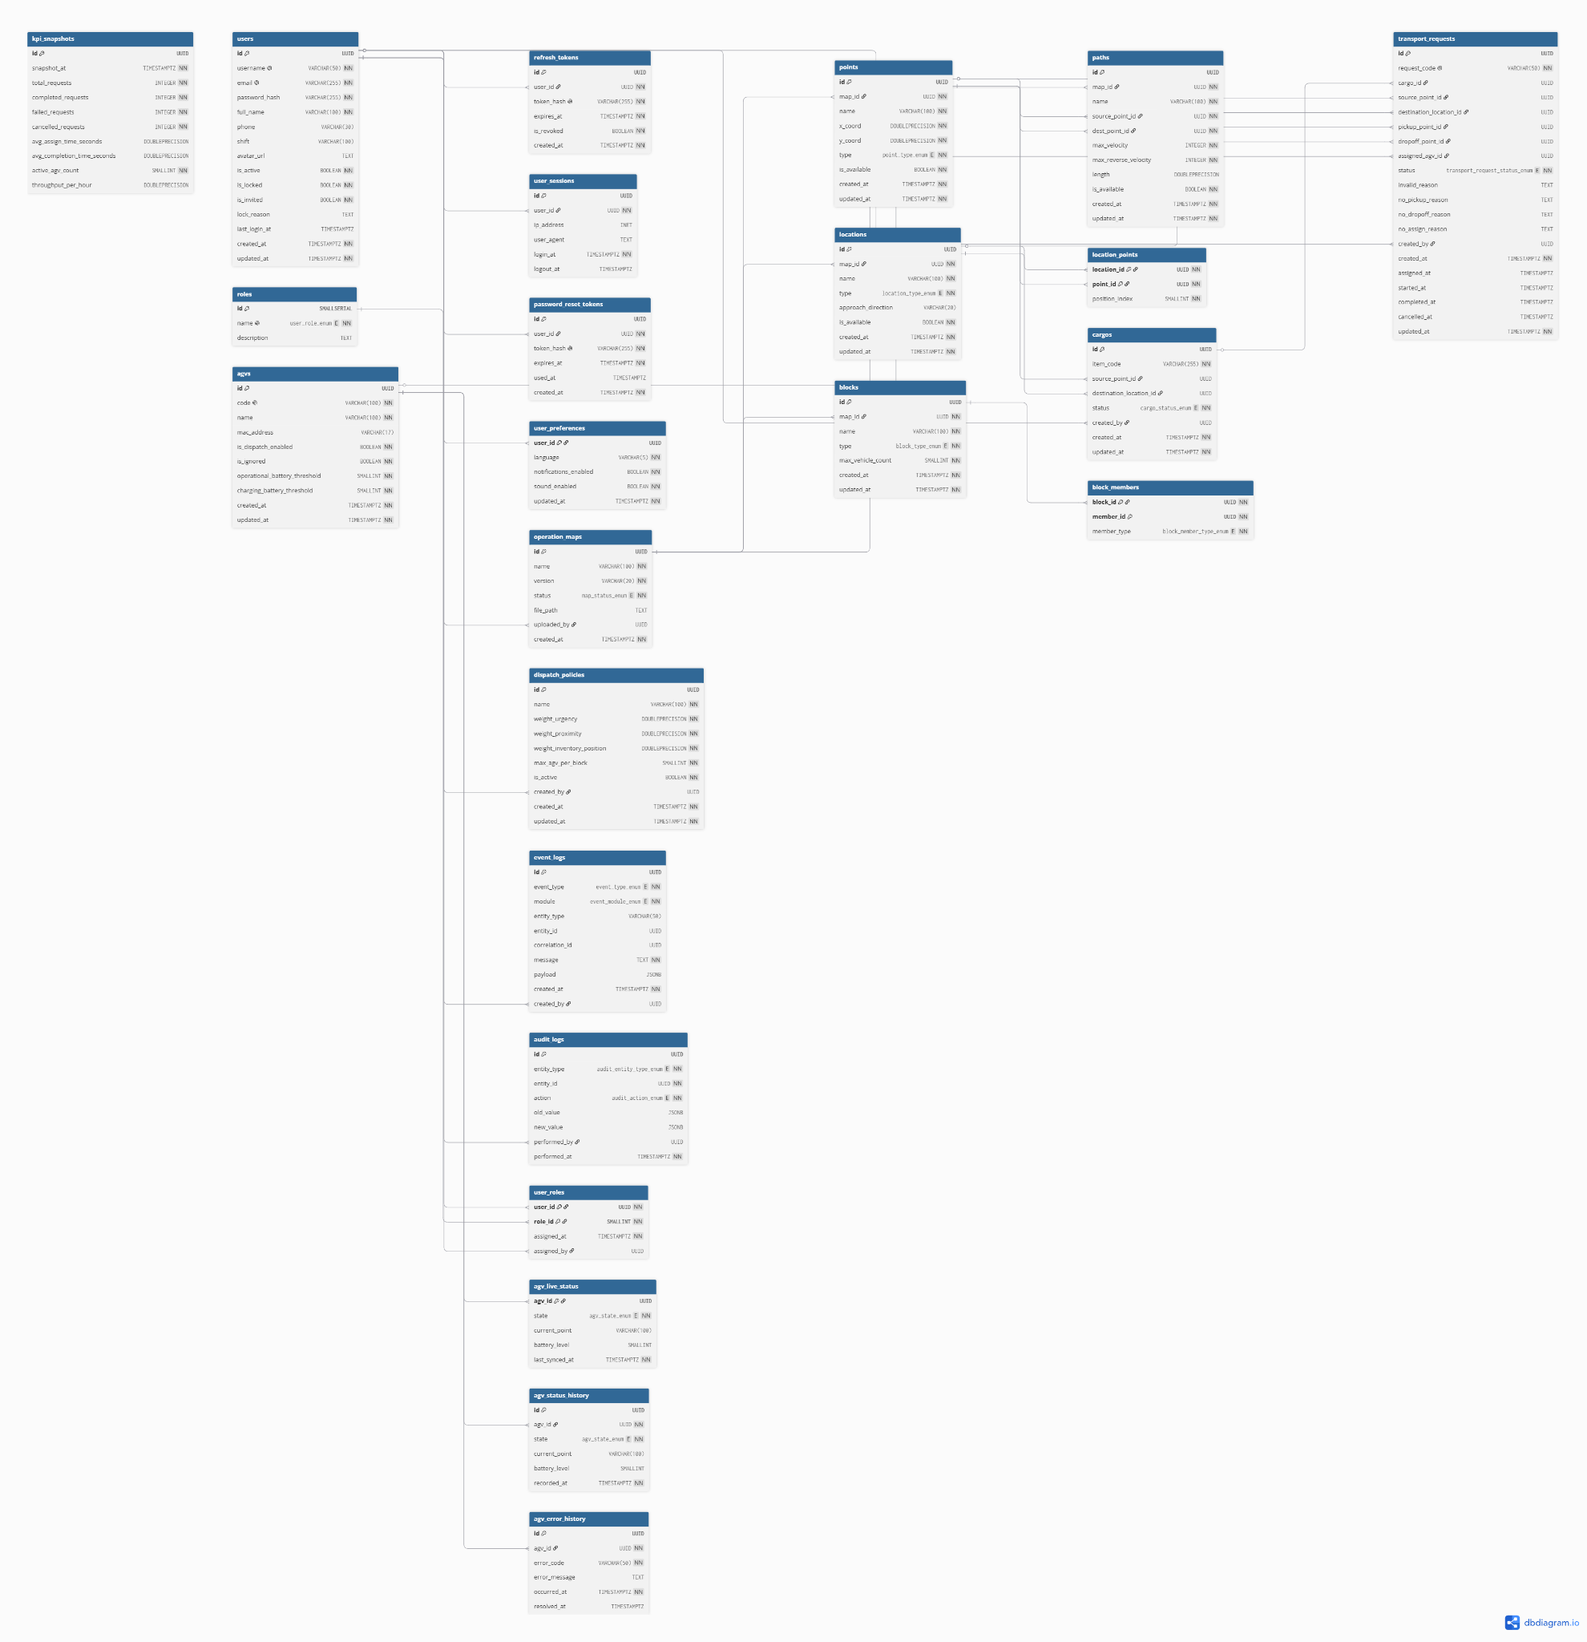
Entities Description
# | Entity | Description
1 | User | Stores system user accounts, profile details (full name, phone, shift, avatar), and authentication/status flags (active, locked, invited).
2 | Role | Defines authorization roles (e.g., ADMIN, OPERATOR) that determine permissions in the system.
3 | User Role | Maps users to roles in a many-to-many relationship to assign system privileges.
4 | Refresh Token | Stores refresh tokens used to keep user authentication sessions active securely.
5 | User Session | Logs login and logout details, IP addresses, and user-agent strings for security audit trails.
6 | Password Reset Token | Stores temporary, single-use security tokens generated for password reset/recovery requests.
7 | User Preference | Stores custom user interface preferences such as language, sound, and notification options.
8 | AGV | Manages Automated Guided Vehicles (AGVs) fleet configuration, codes and serial numbers, and battery threshold parameters.
12 | Operation Map | Records each warehouse floor map uploaded to the system: its name, original file name, the number of points, paths and vehicles it defines, and who uploaded it and when. The active topology itself lives in the openTCS plant model, not in this table.
15 | Location | Represents logical warehouse locations (stations) where specific operations (PICKUP, DROPOFF, CHARGE) are performed.
16 | Location Point | Maps locations to coordinate points and encodes position indices for pickup/dropoff priority ordering.
19 | Transport Request | Manages logistics transportation jobs, tracking source/destination, assigned vehicles, state changes, and assignment failure details.
20 | Dispatch Policy | Defines rule weights (urgency, proximity, position) and capacity limits used by the scheduling algorithm.
21 | KPI Snapshot | Records periodically aggregated Key Performance Indicators (total requests, completion rates, throughput, vehicle count).
22 | Event Log | Logs diagnostic and error event messages categorized by subsystems (AGV, MAP, TRANSPORT, DISPATCH, etc.).
23 | Audit Log | Logs configuration changes (Create, Update, Delete) made to system entities by administrators for audit tracking.
24 | Cargo | Represents a physical goods unit registered in the system. Stores item identity (barcode), source pickup point, destination drop-off location, and lifecycle status (ACTIVE, DELIVERED, CANCELLED)

2. Use Case Specifications

2.1 AGV Fleet Management

2.1.1 Create AGV
Primary Actors | Admin | Secondary Actors | None
Description | As an Admin, I want to add a new AGV to the system so that it can be tracked, dispatched, and managed by WES.
Preconditions | Admin is logged in. The AGV code is known and not yet registered in the system.
Postconditions | - AGV record created with dispatch enabled and not ignored.  - The vehicle is not yet linked to the fleet kernel and shows state UNKNOWN until activated.  - AGV visible in the AGV list.  - Audit log entry written.
Normal Sequence/Flow | Create AGV  - Admin navigates to AGV Management > Create AGV.  - System displays the Create AGV form.  - Admin inputs: Code, Name, Model, Manufacturer, Serial Number, Critical Battery Threshold (%), Sufficient Battery Threshold (%).  - Admin submits the form.  - System validates all fields (required fields, unique code, valid threshold ranges).  - System creates the AGV record with dispatch enabled and not ignored.  - System writes audit log entry.  - System redirects Admin to AGV detail page with success toast.
Alternative Sequences/Flows | Step 5_Duplicate code  System shows inline error: "This AGV code is already registered." Form is not submitted.  Step 5_Invalid battery thresholds  Critical threshold >= sufficient threshold: System shows "Critical threshold must be lower than the sufficient threshold."  Step 5_Required field empty  System shows field-level error: "This field is required." under each empty required field.
Business Rules | BR-01 - criticalBatteryThreshold must be lower than sufficientBatteryThreshold; the relationship is validated before the record is saved.

2.1.2 Update AGV Information
Primary Actors | Admin | Secondary Actors | None
Description | As an Admin, I want to modify an existing AGV's details so that the system reflects accurate hardware information and battery configuration.
Preconditions | Admin is logged in. Target AGV exists in the system.
Postconditions | - AGV record updated with new values.  - Audit log entry written.
Normal Sequence/Flow | Update AGV Information  - Admin navigates to AGV detail page.  - Admin clicks Edit.  - System displays editable form pre-filled with current values.  - Admin modifies desired fields (Name, Model, Critical Threshold, Sufficient Threshold).  - Admin submits.  - System validates all inputs.  - System updates AGV record.  - System writes audit log.  - System shows success toast and returns to AGV detail view.
Alternative Sequences/Flows | Step 6_Invalid inputs  System shows field-level errors; changes are not saved.  Step 6_Invalid threshold relationship  System shows: "Critical threshold must be lower than the sufficient threshold."
Business Rules | BR-01 - the threshold relationship is re-validated on every update.

2.1.3 Delete AGV
Primary Actors | Admin | Secondary Actors | None
Description | As an Admin, I want to permanently remove an AGV record from the system so that decommissioned vehicles no longer appear in dispatch or monitoring.
Preconditions | Admin is logged in. AGV exists in the system. AGV has no active transport task (not DELIVERING or PICKING_UP).
Postconditions | - AGV record permanently deleted.  - AGV no longer visible in the AGV list.  - Audit log entry written.
Normal Sequence/Flow | Delete AGV  - Admin navigates to AGV detail page.  - Admin clicks Delete.  - System shows confirmation dialog: "This action cannot be undone. Continue?"  - Admin confirms.  - System validates AGV has no active transport task.  - System deletes AGV record.  - System writes audit log.  - System redirects Admin to AGV list with success toast.
Alternative Sequences/Flows | Step 5_AGV has active task  System shows error: "Cannot delete an AGV with an active transport task. Disable it first." Delete is blocked.  Step 4_Admin cancels dialog  Dialog closes; no action taken.
Business Rules | None.

2.1.4 View AGV List
Primary Actors | Admin | Secondary Actors | None
Description | As an Admin, I want to view a list of all registered AGVs so that I can monitor fleet status at a glance.
Preconditions | Admin is logged in.
Postconditions | AGV list displayed with up-to-date status.
Normal Sequence/Flow | View AGV List  - Admin navigates to AGV Management.  - System loads and displays a paginated AGV list with columns: Name, Model, Code, Live Status, Battery %, Acceptance Status.  - User can sort by column header and navigate pages.
Alternative Sequences/Flows | No AGVs registered  System shows empty state: "No AGVs registered yet."
Business Rules | None.

2.1.5 View AGV Details
Primary Actors | Admin | Secondary Actors | None
Description | As an Admin, I want to view all properties and real-time status of a specific AGV so that I can assess its operational state.
Preconditions | Admin is logged in. AGV exists in the system.
Postconditions | AGV detail page displayed with latest data synced from FMS.
Normal Sequence/Flow | View AGV Details  - Admin clicks on an AGV entry in the AGV list.  - System displays AGV detail page: Name, Model, Code, Critical Threshold, Sufficient Threshold, Live Status, Battery Level, Current Position, Acceptance Status.
Alternative Sequences/Flows | AGV not found  System shows: "AGV not found."
Business Rules | None.

2.1.6 Configure Critical Battery Threshold
Primary Actors | Admin | Secondary Actors | None
Description | As an Admin, I want to set the minimum battery percentage for AGV task eligibility so that AGVs with insufficient battery are excluded from dispatch.
Preconditions | Admin is logged in. AGV exists in the system.
Postconditions | - Critical threshold updated.  - New value applied in the next dispatch cycle.  - Audit log written.
Normal Sequence/Flow | Configure Critical Battery Threshold  - Admin opens AGV detail page > Edit.  - Admin updates the Critical Battery Threshold field (integer 0–100).  - Admin saves.  - System validates: value must be a positive integer and less than the sufficient threshold.  - System updates AGV record.  - System writes audit log.  - System shows success toast.
Alternative Sequences/Flows | Step 4_Value >= sufficient threshold  System shows: "Critical threshold must be less than the sufficient threshold."
Business Rules | BR-01 - this value must stay below the sufficient threshold.  BR-02 - an AGV joins the assignment candidate set only while its battery level is above this threshold.

2.1.7 Configure Sufficient Battery Threshold
Primary Actors | Admin | Secondary Actors | None
Description | As an Admin, I want to set the battery percentage that forces an AGV to stop accepting tasks and go charge so that AGVs never run out of power mid-task.
Preconditions | Admin is logged in. AGV exists in the system.
Postconditions | - Sufficient threshold updated.  - Audit log written.
Normal Sequence/Flow | Configure Sufficient Battery Threshold  - Admin opens AGV detail page > Edit.  - Admin updates the Sufficient Battery Threshold field (integer 0–100).  - Admin saves.  - System validates: value must be greater than the critical threshold.  - System updates AGV record.  - System writes audit log.  - System shows success toast.
Alternative Sequences/Flows | Step 4_Value <= critical threshold  System shows: "Sufficient threshold must be greater than the critical threshold."
Business Rules | BR-01 - this value must stay above the critical threshold.  BR-03 - a charging AGV is released back into dispatch at or above this threshold, when there is demand.

2.1.8 Enable AGV to Accept Requests
Primary Actors | Admin | Secondary Actors | None
Description | As an Admin, I want to manually allow an AGV to receive dispatch commands so that it re-enters the assignment pool after being disabled or serviced.
Preconditions | Admin is logged in. AGV exists. AGV acceptance status is currently DISABLED or IGNORED.
Postconditions | - AGV acceptance status = ENABLED.  - AGV eligible for next dispatch cycle.  - Audit log written.
Normal Sequence/Flow | Enable AGV to Accept Requests  - Admin navigates to AGV detail page.  - Admin clicks "Enable".  - System updates acceptance status to ENABLED.  - System writes audit log.  - System shows success toast; button state updates.
Alternative Sequences/Flows | Already enabled  "Enable" button is hidden or disabled; no action possible.
Business Rules | None. The dispatch-enabled flag is not yet covered by a business rule.

2.1.9 Disable AGV from Accepting Requests
Primary Actors | Admin | Secondary Actors | None
Description | As an Admin, I want to stop an AGV from receiving new dispatch assignments so that I can service or reserve it without deleting its record.
Preconditions | Admin is logged in. AGV acceptance status is ENABLED.
Postconditions | - AGV acceptance status = DISABLED.  - AGV excluded from next dispatch cycle.  - Audit log written.
Normal Sequence/Flow | Disable AGV from Accepting Requests  - Admin navigates to AGV detail page.  - Admin clicks "Disable".  - System shows confirmation dialog.  - Admin confirms.  - System sets acceptance status to DISABLED.  - System writes audit log.  - System shows success toast.
Alternative Sequences/Flows | Step 4_AGV has active task  System shows warning: "AGV is executing a task. It will be excluded from new assignments after the current task completes." Admin may proceed or cancel.
Business Rules | None. The dispatch-enabled flag is not yet covered by a business rule.

2.1.10 Ignore AGV from the System
Primary Actors | Admin | Secondary Actors | None
Description | As an Admin, I want to exclude an AGV from all orchestration without deleting it so that maintenance vehicles do not interfere with dispatch logic.
Preconditions | Admin is logged in. AGV exists and is not already IGNORED.
Postconditions | - AGV status = IGNORED.  - AGV excluded from all dispatch logic and monitoring.  - Audit log written.
Normal Sequence/Flow | Ignore AGV from the System  - Admin navigates to AGV detail page.  - Admin clicks "Ignore".  - System shows confirmation: "This AGV will be excluded from all orchestration. Continue?"  - Admin confirms.  - System sets AGV status to IGNORED.  - System writes audit log.  - System shows success toast.
Alternative Sequences/Flows | Step 4_AGV has active task  System warns: "AGV has an active transport task. Ignoring it now may cause task failure." Admin can proceed or cancel.
Business Rules | BR-06 - an ignored AGV is excluded from all dispatch logic including the forced charging cycle, but remains a spatial obstacle in fleet routing.

2.1.11 Restore Ignored AGV
Primary Actors | Admin | Secondary Actors | None
Description | As an Admin, I want to re-include a previously ignored AGV into WES orchestration so that it becomes available for dispatch again.
Preconditions | Admin is logged in. AGV status = IGNORED.
Postconditions | - AGV status reverts to live status synced from FMS.  - AGV acceptance = ENABLED.  - AGV re-enters the orchestration pool.  - Audit log written.
Normal Sequence/Flow | Restore Ignored AGV  - Admin navigates to AGV detail page.  - Admin clicks "Restore".  - System sets AGV status to live status from FMS sync (e.g., UNKNOWN, IDLE).  - System sets acceptance status to ENABLED.  - System writes audit log.  - System shows success toast.
Alternative Sequences/Flows | None.
Business Rules | BR-06 - restoring the AGV returns it to dispatch logic; its status never affected collision avoidance.

2.1.12 View AGV Request Acceptance Status
Primary Actors | Admin | Secondary Actors | FMS (openTCS)
Description | As an Admin, I want to activate or deactivate the link between an AGV and the fleet kernel, so that only vehicles physically present and ready are tracked and controlled by the system.
Preconditions | Admin is logged in. The AGV is registered in WES and a vehicle of the same name exists in the active plant model. The FMS kernel is reachable.
Postconditions | Activate: the communication adapter is enabled and the integration level is set to TO_BE_UTILIZED; the kernel reports the vehicle state and position and may assign it orders.  Deactivate: the integration level is set to TO_BE_IGNORED and the adapter is disabled; the kernel stops tracking the vehicle and it receives no further orders.  Audit log entry written.
Normal Sequence/Flow | Activate / Deactivate AGV  - Admin opens the AGV list and selects the target vehicle.  - To activate: Admin clicks Activate.  - System enables the communication adapter for that vehicle in the FMS.  - System sets the vehicle integration level to TO_BE_UTILIZED.  - The vehicle publishes its state; the kernel moves it from UNKNOWN to IDLE and reports its current position.  - To deactivate: Admin clicks Deactivate on an active vehicle.  - System sets the vehicle integration level to TO_BE_IGNORED.  - System disables the communication adapter.  - The kernel drops the vehicle state and position; the list shows UNKNOWN.
Alternative Sequences/Flows | Step 4_Kernel unreachable  System shows: "Fleet kernel is not reachable. Try again once the connection is restored." No state is changed.  Step 4_No matching vehicle in the plant model  System shows: "No vehicle named {name} exists in the active map."  Deactivate_Vehicle has an active task  System warns that the current task will be abandoned and requires confirmation before proceeding.  Note: activation is runtime state and is not stored in the plant model. A kernel restart returns every vehicle to UNKNOWN and each vehicle must be activated again.
Business Rules | BR-06 - a deactivated AGV is excluded from dispatch. Note that deactivation also removes it from kernel tracking, so it no longer reserves its position.

2.1.13 Search AGV
Primary Actors | System | Secondary Actors | Admin, FMS (openTCS)
Description | As an operator of the fleet, I need the system to react safely when a vehicle stops communicating while carrying out a transport task, so that its task does not hang silently and other vehicles do not plan through the space it still occupies.
Preconditions | The AGV is activated and is executing a transport task (status PICKING_UP or DELIVERING).
Postconditions | The vehicle is marked unreachable and excluded from new assignments.  Its last known position stays reserved so fleet routing continues to plan around it.  The affected task is flagged for attention and is not silently advanced.  An entry is written to the AGV error history.
Normal Sequence/Flow | Handle AGV Disconnection  - The vehicle stops publishing state; the FMS reports its state as UNKNOWN or UNAVAILABLE.  - System detects the transition and marks the vehicle unreachable.  - System removes the vehicle from the assignment candidate set.  - System keeps the last known position of the vehicle occupied so fleet routing plans around it rather than through it.  - System records the disconnection in the AGV error history with a timestamp and the last known position.  - System raises an alert to the Admin naming the vehicle and the affected task.  - The task stays in its current status, marked as requiring attention; it is neither completed nor silently failed.
Alternative Sequences/Flows | Step 1_Vehicle reconnects  System compares the position reported by the vehicle with the position it last recorded. If they agree, the vehicle returns to the candidate set and the task resumes. If they differ, the vehicle plan is discarded and routing is recomputed from the reported position.  Step 6_Admin intervenes  Admin may cancel the affected task, or confirm that the vehicle has been physically cleared, which releases its reserved position.  Note: the system never releases the position of a vehicle it cannot see. A physical vehicle occupies its position regardless of connectivity; only an explicit Admin confirmation releases it.
Business Rules | BR-06 - the disconnected AGV is excluded from assignment but its last known position stays reserved: exclusion applies to work allocation only, never to collision avoidance.

2.1.14 Filter AGVs by Status
Primary Actors | Admin | Secondary Actors | None
Description | As an Admin, I want to filter the AGV list by operational status so that I can focus on a specific subset of vehicles.
Preconditions | Admin is logged in.
Postconditions | AGV list filtered and displayed according to selected status(es).
Normal Sequence/Flow | Filter AGVs by Status  - Admin opens the filter panel on the AGV list page.  - Admin selects one or more statuses: IDLE, EXECUTING, CHARGING, ERROR, UNAVAILABLE, UNKNOWN, Ignored.  - System applies the filter and refreshes the list.  - Active filter tags displayed above the list.
Alternative Sequences/Flows | No AGVs match selected filter  System shows empty state with applied filter labels visible.
Business Rules | None.

2.1.15 View AGV Operation History
Primary Actors | Admin | Secondary Actors | None
Description | As an Admin, I want to view the chronological task history of an AGV so that I can audit its operational performance.
Preconditions | Admin is logged in. AGV exists.
Postconditions | Operation history displayed in paginated list.
Normal Sequence/Flow | View AGV Operation History  - Admin navigates to AGV detail page > Operation History tab.  - System loads paginated list of historical tasks: Task ID, Source, Destination, Start Time, End Time, Status.  - Admin can filter by date range.
Alternative Sequences/Flows | No history  System shows: "No operation history recorded yet."
Business Rules | None.

2.1.16 View AGV Error History
Primary Actors | Admin | Secondary Actors | None
Description | As an Admin, I want to view the log of errors triggered by an AGV so that I can diagnose recurring hardware or software issues.
Preconditions | Admin is logged in. AGV exists.
Postconditions | Error history displayed in paginated list.
Normal Sequence/Flow | View AGV Error History  - Admin navigates to AGV detail page > Error History tab.  - System loads paginated list of error events: Error Code, Message, Timestamp, Resolved At.  - Admin can filter by date range or error code.
Alternative Sequences/Flows | No errors recorded  System shows: "No errors recorded for this AGV."
Business Rules | None.

2.2 Warehouse Map & Topology

2.2.1 Upload New Operation Map
Primary Actors | Admin | Secondary Actors | None
Description | As an Admin, I want to upload a new warehouse floor map file so that I can define the topology on top of it.
Preconditions | Admin is logged in. No other map upload is currently in progress.
Postconditions | - New map stored with status DRAFT.  - Admin can begin defining points and paths on the new map.  - Audit log written.
Normal Sequence/Flow | Upload New Operation Map  - Admin navigates to Warehouse Map > Upload Map.  - System displays the upload form.  - Admin selects a map file (supported formats: PNG, SVG) and enters a map name.  - Admin submits.  - System validates file format and size.  - System stores map with status DRAFT.  - System writes audit log.  - System shows success toast and redirects to the map editing view.
Alternative Sequences/Flows | Step 5_Unsupported file format  System shows: "Only PNG and SVG files are supported."  Step 5_File too large  System shows: "File size exceeds the maximum limit."
Business Rules | None.

2.2.2 Replace Current Operation Map
Primary Actors | Admin | Secondary Actors | None
Description | As an Admin, I want to replace the active warehouse map with a new file so that the system reflects the updated physical layout.
Preconditions | Admin is logged in. An ACTIVE map exists. No AGV is currently executing a transport task.
Postconditions | - Previous map status set to ARCHIVED.  - New map set to ACTIVE.  - Existing topology entities preserved but flagged for re-verification.  - Audit log written.
Normal Sequence/Flow | Replace Current Operation Map  - Admin navigates to Warehouse Map > Replace Map.  - System shows warning: "Replacing the map will archive the current one. All topology must be re-verified. Continue?"  - Admin confirms and uploads the new map file.  - System validates the new file.  - System archives the current map (status = ARCHIVED).  - System activates the new map (status = ACTIVE).  - System writes audit log.  - System shows success toast.
Alternative Sequences/Flows | Step 2_AGVs have active tasks  System blocks: "Cannot replace map while AGVs have active transport tasks."  Step 3_Admin cancels warning  No action taken.
Business Rules | None.

2.2.15 Create Operational Location
Primary Actors | Admin | Secondary Actors | None
Description | As an Admin, I want to group map points into a named operational location so that WES can reference it as a pickup, drop-off, or charging zone.
Preconditions | Admin is logged in. At least one unassigned point exists on the active map.
Postconditions | - Location created with assigned points, type, and position indices.  - Audit log written.
Normal Sequence/Flow | Create Operational Location  - Admin navigates to Warehouse Map > Locations > Create Location.  - Admin inputs: Name, Type (PICKUP / DROPOFF / CHARGE), selects one or more points to assign.  - For PICKUP/DROPOFF: Admin sets a position index for each point (defines slot priority order).  - Admin saves.  - System validates (unique name, at least one point, valid type).  - System creates the Location and LocationPoint mapping records.  - System writes audit log.  - System shows success toast.
Alternative Sequences/Flows | Step 5_Duplicate location name  System shows: "Location name already exists."  Step 5_No points selected  System shows: "At least one point must be assigned to the location."
Business Rules | BR-10 and BR-11 - the position index assigned to each member point determines pickup order (outer before inner) and drop-off fill order.

2.2.16 Update Operational Location
Primary Actors | Admin | Secondary Actors | None
Description | As an Admin, I want to modify an existing operational location's name and colour so that it stays readable on the operation map. Member points and the location type are not changed here - see UC 35 and UC 36.
Preconditions | Admin is logged in. Location exists.
Postconditions | - Location record updated.  - Audit log written.
Normal Sequence/Flow | Update Operational Location  - Admin navigates to location detail and clicks Edit.  - Admin modifies desired fields (Name, Type, point assignments, position indices).  - Admin saves.  - System validates inputs.  - System updates the location record.  - System writes audit log.  - System shows success toast.
Alternative Sequences/Flows | Step 3_Location referenced by active task  System warns: "This location is referenced by an active transport task. Changes will apply to subsequent tasks only." Admin may proceed or cancel.
Business Rules | BR-12 - name and colour may be changed at any time. Member points and the location type are outside the scope of this use case.

2.2.17 Delete Operational Location
Primary Actors | Admin | Secondary Actors | None
Description | As an Admin, I want to remove an operational location from the system so that decommissioned zones no longer appear in transport task configuration.
Preconditions | Admin is logged in. Location exists. Location is not referenced by any active transport task.
Postconditions | - Location and all LocationPoint mappings deleted.  - Assigned points released to unassigned state.  - Audit log written.
Normal Sequence/Flow | Delete Operational Location  - Admin navigates to location detail and clicks Delete.  - System shows confirmation dialog.  - Admin confirms.  - System validates no active task references this location.  - System deletes the location and all LocationPoint records.  - System writes audit log.  - System shows success toast.
Alternative Sequences/Flows | Step 4_Location referenced by active task  System blocks: "Cannot delete a location currently used by an active transport task."
Business Rules | BR-12 - the location may be deleted only while no active cargo holds it as its source or destination zone.

2.2.18 View Operational Location List
Primary Actors | Admin, Operator | Secondary Actors | None
Description | As a user, I want to view all defined operational locations so that I can understand the warehouse zone configuration.
Preconditions | User is logged in.
Postconditions | Location list displayed.
Normal Sequence/Flow | View Operational Location List  - User navigates to Warehouse Map > Locations.  - System displays a list: Location Name, Type (PICKUP/DROPOFF/CHARGE), Number of Points.
Alternative Sequences/Flows | No locations defined  System shows: "No operational locations defined."
Business Rules | None.

2.2.19 View Operational Location Detail
Primary Actors | Admin, Operator | Secondary Actors | None
Description | As a user, I want to view the full details of a specific operational location so that I can understand its type, assigned slot points, and current availability status.
Preconditions | User is logged in. Operational location exists.
Postconditions | Location detail page displayed.
Normal Sequence/Flow | - User clicks on an entry in the Operational Location list (UC 2.2.18).  - System displays the Location detail page: Location Name, Type (PICKUP / DROPOFF / CHARGE), Assigned Points list (Position Index, Point Name, Coordinates for each slot), Availability Status, count of Active Transport Requests currently referencing this location.
Alternative Sequences/Flows | Location not found: System shows: "Operational location not found."
Business Rules | None.

2.2.20 Assign Point to Location
Primary Actors | Admin | Secondary Actors | None
Description | As an Admin, I want to add a map point to an existing location so that the zone gains an additional slot for AGV operations.
Preconditions | Admin is logged in. Location and target point exist. Point is not already assigned to this location.
Postconditions | - LocationPoint mapping created with position index.  - Audit log written.
Normal Sequence/Flow | Assign Point to Location  - Admin navigates to location detail > Manage Points > Assign Point.  - Admin selects an unassigned point from the dropdown.  - Admin sets the position index for the point within this location.  - Admin saves.  - System creates the LocationPoint record.  - System writes audit log.  - System shows success toast.
Alternative Sequences/Flows | Step 5_Point already assigned to this location  System shows: "This point is already assigned to this location."
Business Rules | BR-12 - a member point may be added only while no active cargo references the location.  BR-10 and BR-11 - the new position index takes part in pickup and drop-off ordering from the moment it is added.

2.2.21 Remove Point from Location
Primary Actors | Admin | Secondary Actors | FMS (openTCS)
Description | As an Admin, I want to remove a map point from an operational location so that the location no longer offers that slot for AGV operations.
Preconditions | Admin is logged in. The operational location exists and has more than one member point. No active cargo holds the location as its source or destination zone.
Postconditions | - The member point is unmapped from the location and the capacity of the location drops by one.  - If the point is not shared with another location, its entry is removed from the openTCS plant model.  - Audit log written.
Normal Sequence/Flow | Remove Point from Location  - Admin opens the operational location detail panel.  - Admin selects the member point to remove.  - Admin confirms the removal.  - System verifies that no active cargo references the location.  - System removes the member mapping and re-checks the position indices of the remaining points.  - System updates the openTCS plant model if the point is no longer used by any location.  - System writes an audit log entry.  - System shows the updated member list.
Alternative Sequences/Flows | Step 4_Location is in use  System shows: "This location has active cargo. Remove the point once the cargo has been delivered." No change is made.  Step 2_Last remaining point  System shows: "Cannot remove the last point. Delete the location instead."  Step 6_Kernel unreachable  System shows: "Fleet kernel is not reachable. Try again once the connection is restored." and the change is rolled back.
Business Rules | BR-12 - a member point may be removed only while no active cargo references the location.  BR-10 and BR-11 - removing a point changes the pickup and drop-off ordering of the remaining slots.

2.2.22 Set Kernel Operating Mode
Primary Actors | Admin | Secondary Actors | FMS (openTCS)
Description | As an Admin, I want to switch the fleet kernel between MODELLING and OPERATING so that I can upload a new plant model or resume normal dispatching.
Preconditions | Admin is logged in. The FMS kernel is reachable.
Postconditions | - The kernel reports the requested mode.  - In MODELLING the kernel accepts a new plant model and does not dispatch; in OPERATING it resumes dispatching.  - Audit log written.
Normal Sequence/Flow | Set Kernel Operating Mode  - Admin opens Map Management.  - System displays the current kernel mode.  - Admin selects the target mode (MODELLING or OPERATING).  - System sends the mode change to the FMS kernel.  - The kernel confirms the change and System displays the new mode.
Alternative Sequences/Flows | Step 5_Kernel unreachable  System shows: "Fleet kernel is not reachable. Try again once the connection is restored." The mode is not changed.  Step 4_Vehicles are executing orders  System warns that switching to MODELLING stops dispatching and requires confirmation before proceeding.
Business Rules | None.

2.2.23 Synchronise Operational Locations with the Plant Model
Primary Actors | Admin | Secondary Actors | FMS (openTCS)
Description | As an Admin, I want to re-check every operational location against the active plant model so that locations whose points no longer exist are flagged before they break dispatching.
Preconditions | Admin is logged in. The FMS kernel is reachable.
Postconditions | - Every operational location is re-evaluated.  - A location whose member points still exist and which does not conflict with another location stays ACTIVE; otherwise it is marked STALE.  - System reports how many locations were checked, how many became stale and how many were restored to active.
Normal Sequence/Flow | Synchronise Operational Locations  - Admin opens the operational location panel.  - Admin triggers Synchronise.  - System re-reads the active plant model from the kernel, bypassing any cached copy.  - System checks the member points of each location against the model.  - A member location claimed by two or more locations disqualifies every location that touches it, and each of them is marked STALE.  - System saves the new statuses and displays the summary.
Alternative Sequences/Flows | Step 4_Kernel unreachable  Synchronisation is skipped, no status is changed, and the summary reports that the kernel could not be reached.
Business Rules | None. Synchronisation only re-evaluates status; it never adds or removes member points, so BR-12 does not apply.

2.3 User & Access Management

2.3.1 System Login
Primary Actors | Admin, Operator | Secondary Actors | Gmail Service
Description | As a user, I want to log in to the system with my email and password so that I can access authenticated features.
Preconditions | User account exists and is not locked.
Postconditions | - User session created.  - User directed to home page (or previously requested page).  - Session entry (IP, user-agent, timestamp) written to User Session log.
Normal Sequence/Flow | System Login  - User navigates to the login page.  - User enters username and password.  - User clicks Login.  - System validates credentials (username exists, password matches, account is active and not locked).  - System creates session and refresh token.  - System logs session (IP, user-agent, login timestamp).  - System redirects user to home page.
Alternative Sequences/Flows | Step 4_Wrong credentials  System shows: "Incorrect username or password." (MSG09)  Step 4_Account locked  System shows: "Your account has been locked. Contact your administrator." (MSG12)  Step 4_5 consecutive failures  System locks the account for 30 minutes and shows lockout warning (MSG13).  Step 4_Email not verified  System shows: "Please verify your email before logging in." (MSG11)

2.3.2 System Logout
Primary Actors | Admin, Operator | Secondary Actors | None
Description | As a user, I want to log out of the system so that my session is terminated and my account is secured.
Preconditions | User is logged in with an active session.
Postconditions | - Session invalidated. Refresh token revoked.  - User redirected to login page.  - Session end time logged.
Normal Sequence/Flow | System Logout  - User clicks Logout.  - System invalidates the active session and revokes the refresh token.  - System logs session end timestamp.  - System redirects user to the login page.
Alternative Sequences/Flows | None.

2.3.3 View Personal Info
Primary Actors | Admin, Operator | Secondary Actors | None
Description | As a user, I want to view my own profile details so that I can confirm my account information is correct.
Preconditions | User is logged in.
Postconditions | Profile page displayed with current data.
Normal Sequence/Flow | View Personal Info  - User navigates to Profile / My Account.  - System displays: Full Name, Email (read-only), Phone, Shift, Role(s), Avatar.
Alternative Sequences/Flows | None.

2.3.4 Update Personal Info (Profile)
Primary Actors | Admin, Operator | Secondary Actors | None
Description | As a user, I want to update my profile information so that my contact details and preferences stay current. Email cannot be changed by the user.
Preconditions | User is logged in.
Postconditions | - Profile updated with new values.  - Audit log written.
Normal Sequence/Flow | Update Personal Info  - User navigates to Profile > Edit.  - System displays an editable form with current values (email shown as read-only).  - User modifies desired fields: Full Name, Phone, Shift, Avatar.  - User saves.  - System validates inputs (name max length, valid phone format).  - System updates the user record.  - System writes audit log.  - System shows success toast.
Alternative Sequences/Flows | Step 5_Invalid phone format  System shows: "Invalid phone number format."

2.3.5 Change Password
Primary Actors | Admin, Operator | Secondary Actors | None
Description | As a user, I want to change my password after verifying my current one so that I can maintain account security.
Preconditions | User is logged in.
Postconditions | - Password updated.  - All other active sessions for this user are invalidated.  - Audit log written.
Normal Sequence/Flow | Change Password  - User navigates to Profile > Change Password.  - User enters: Current Password, New Password, Confirm New Password.  - User submits.  - System validates that the current password is correct.  - System validates that the new password meets the security policy (minimum 8 characters, mixed types).  - System validates that new password matches confirm password.  - System hashes and stores the new password.  - System invalidates all other active sessions for this user.  - System writes audit log.  - System shows success toast.
Alternative Sequences/Flows | Step 4_Wrong current password  System shows: "Current password is incorrect."  Step 5_Password policy violation  System shows the specific policy error message.  Step 6_Confirm mismatch  System shows: "Passwords do not match."

2.3.6 Forgot / Reset Password
Primary Actors | Admin, Operator | Secondary Actors | Gmail Service
Description | As a user who forgot my password, I want to receive a secure OTP via email so that I can reset my password and regain access.
Preconditions | User account exists and is active (not locked).
Postconditions | - Password successfully reset; old password invalidated.  - OTP token invalidated (single-use).  - Audit log written.
Normal Sequence/Flow | Forgot / Reset Password  - User clicks "Forgot Password" on the login page.  - User enters their registered email address.  - System validates the email exists and the account is active.  - System generates a single-use OTP token (expires in 15 minutes).  - System sends the OTP to the user's email via Gmail Service.  - User enters the OTP on the password reset page.  - System validates the OTP (correct, not expired, not previously used).  - User enters and confirms a new password.  - System validates the new password meets the security policy.  - System stores the new hashed password and invalidates the OTP token.  - System writes audit log.  - System shows success message and redirects to the login page.
Alternative Sequences/Flows | Step 3_Email not found  System shows: "If this email is registered, you will receive a reset link." (Security: no disclosure.)  Step 7_OTP expired  System shows: "OTP has expired. Please request a new one."  Step 7_OTP already used  System shows: "This OTP has already been used."

2.3.7 Create User Account
Primary Actors | Admin | Secondary Actors | Gmail Service
Description | As an Admin, I want to create a new user account and send an invitation email so that the new user can log in and access the system.
Preconditions | Admin is logged in. The target email address is not already registered in the system.
Postconditions | - User account created with status INVITED.  - Invitation email sent via Gmail Service.  - Audit log written.
Normal Sequence/Flow | Create User Account  - Admin navigates to User Management > Create User.  - Admin inputs: Full Name, Email, Role (Admin / Operator), Phone (optional), Shift (optional).  - Admin submits.  - System validates (email is unique, valid format, required fields present).  - System creates user account with status = INVITED.  - System generates an invite/setup link (expires in 48 hours).  - System sends invitation email via Gmail Service.  - System writes audit log.  - System shows success toast.
Alternative Sequences/Flows | Step 4_Duplicate email  System shows: "An account with this email already exists."  Step 7_Email delivery failure  Account is created. System shows warning: "Account created but invitation email failed to send. Share the setup link manually."

2.3.8 Update User Account
Primary Actors | Admin | Secondary Actors | None
Description | As an Admin, I want to edit another user's account details so that their profile stays accurate.
Preconditions | Admin is logged in. Target user account exists.
Postconditions | - User account updated.  - Audit log written.
Normal Sequence/Flow | Update User Account  - Admin navigates to User Management > select user > Edit.  - Admin modifies desired fields: Full Name, Phone, Shift. (Email and Role are managed separately.)  - Admin saves.  - System validates inputs.  - System updates the user record.  - System writes audit log.  - System shows success toast.
Alternative Sequences/Flows | Step 4_Invalid inputs  System shows field-level validation errors; changes not saved.

2.3.9 Delete User Account
Primary Actors | Admin | Secondary Actors | None
Description | As an Admin, I want to permanently delete a user account so that former personnel lose all system access.
Preconditions | Admin is logged in. Target user account exists. Admin is not deleting their own account.
Postconditions | - User account permanently deleted.  - All active sessions for that user are immediately invalidated.  - Audit log written.
Normal Sequence/Flow | Delete User Account  - Admin navigates to User Management > select user > Delete.  - System shows confirmation dialog: "This will permanently remove the account. Continue?"  - Admin confirms.  - System validates Admin is not deleting their own account.  - System deletes the user record and invalidates all active sessions.  - System writes audit log.  - System redirects Admin to User list with success toast.
Alternative Sequences/Flows | Step 4_Admin attempts to delete own account  System blocks: "You cannot delete your own account."  Step 3_Admin cancels dialog  No action taken.

2.3.10 View User List
Primary Actors | Admin | Secondary Actors | None
Description | As an Admin, I want to view a list of all registered users so that I can manage accounts and monitor access.
Preconditions | Admin is logged in.
Postconditions | User list displayed.
Normal Sequence/Flow | View User List  - Admin navigates to User Management.  - System displays a paginated list: Full Name, Email, Role(s), Account Status, Last Login.
Alternative Sequences/Flows | No users registered  System shows: "No users registered yet."

2.3.11 View User Details
Primary Actors | Admin | Secondary Actors | None
Description | As an Admin, I want to view a specific user's full profile and account information so that I can manage their access correctly.
Preconditions | Admin is logged in. User account exists.
Postconditions | User detail page displayed.
Normal Sequence/Flow | View User Details  - Admin clicks on a user entry in the user list.  - System displays: Full Name, Email, Phone, Shift, Role(s), Account Status, Created At, Last Login.
Alternative Sequences/Flows | None.

2.3.12 Lock User Account
Primary Actors | Admin | Secondary Actors | None
Description | As an Admin, I want to temporarily lock a user account so that the user cannot log in while retaining their account data.
Preconditions | Admin is logged in. Target user account is ACTIVE (not already locked). Admin is not locking their own account.
Postconditions | - Account status = LOCKED.  - All active sessions for the user are immediately invalidated.  - Audit log written.
Normal Sequence/Flow | Lock User Account  - Admin navigates to User detail page.  - Admin clicks "Lock Account".  - System shows confirmation dialog.  - Admin confirms.  - System sets account status to LOCKED.  - System invalidates all active sessions for this user.  - System writes audit log.  - System shows success toast.
Alternative Sequences/Flows | Step 4_Admin attempts to lock own account  System blocks: "You cannot lock your own account."

2.3.13 Unlock User Account
Primary Actors | Admin | Secondary Actors | None
Description | As an Admin, I want to unlock a locked user account so that the user can log in again.
Preconditions | Admin is logged in. Target account status = LOCKED.
Postconditions | - Account status = ACTIVE.  - User can log in again.  - Audit log written.
Normal Sequence/Flow | Unlock User Account  - Admin navigates to User detail page.  - Admin clicks "Unlock Account".  - System sets account status to ACTIVE.  - System writes audit log.  - System shows success toast.
Alternative Sequences/Flows | None.

2.3.14 Assign Role to User
Primary Actors | Admin | Secondary Actors | None
Description | As an Admin, I want to grant a system role to a user so that they gain the appropriate feature access permissions.
Preconditions | Admin is logged in. Target user account exists. User does not already have the target role.
Postconditions | - UserRole mapping created.  - User gains role permissions on their next authenticated request.  - Audit log written.
Normal Sequence/Flow | Assign Role to User  - Admin navigates to User detail > Roles > Assign Role.  - Admin selects role from dropdown: Admin / Operator.  - Admin confirms.  - System creates the UserRole record.  - System writes audit log.  - System shows success toast.
Alternative Sequences/Flows | Step 3_Role already assigned  System shows: "This user already has the selected role."

2.3.15 Remove Role from User
Primary Actors | Admin | Secondary Actors | None
Description | As an Admin, I want to revoke a role from a user so that they lose access to features associated with that role.
Preconditions | Admin is logged in. Target user has the role being removed. Removal will not leave the user with zero roles.
Postconditions | - UserRole mapping deleted.  - Role permissions revoked; active sessions remain valid but permission checks update on next request.  - Audit log written.
Normal Sequence/Flow | Remove Role from User  - Admin navigates to User detail > Roles.  - Admin clicks Remove next to the target role.  - System shows confirmation dialog.  - Admin confirms.  - System validates user will retain at least one role after removal.  - System deletes the UserRole record.  - System writes audit log.  - System shows success toast.
Alternative Sequences/Flows | Step 5_Last role  System blocks: "Cannot remove the last role. Assign another role first, or delete the account."

2.3.16 Reset User Password
Primary Actors | Admin | Secondary Actors | Gmail Service
Description | As an Admin, I want to force a password reset for a user so that compromised or forgotten passwords are replaced without requiring the user to know their current password.
Preconditions | Admin is logged in. Target user account exists and is ACTIVE.
Postconditions | - Password reset token generated and emailed to user.  - User's current password remains valid until they complete the reset flow.  - Audit log written.
Normal Sequence/Flow | Reset User Password  - Admin navigates to User detail page.  - Admin clicks "Reset Password".  - System shows confirmation dialog.  - Admin confirms.  - System generates a single-use password reset token (expires in 24 hours).  - System sends reset link email via Gmail Service.  - System writes audit log.  - System shows success toast: "Password reset email sent to [user email]."
Alternative Sequences/Flows | Step 6_Email delivery failure  System shows: "Reset token generated but email failed to send. Share the reset link manually with the user."

Primary Actors | Admin | Secondary Actors | Gmail Service
Description | As an Admin, I want to force a password reset for a user so that compromised or forgotten passwords are replaced without requiring the user to know their current password.
Preconditions | Admin is logged in. Target user account exists and is ACTIVE.
Postconditions | - Password reset token generated and emailed to user.  - User's current password remains valid until they complete the reset flow.  - Audit log written.
Normal Sequence/Flow | Reset User Password  - Admin navigates to User detail page.  - Admin clicks "Reset Password".  - System shows confirmation dialog.  - Admin confirms.  - System generates a single-use password reset token (expires in 24 hours).  - System sends reset link email via Gmail Service.  - System writes audit log.  - System shows success toast: "Password reset email sent to [user email]."
Alternative Sequences/Flows | Step 6_Email delivery failure  System shows: "Reset token generated but email failed to send. Share the reset link manually with the user."

3. Functional Requirements

3.1 AGV Fleet Management

3.1.1 AGV List
Related use case(s):
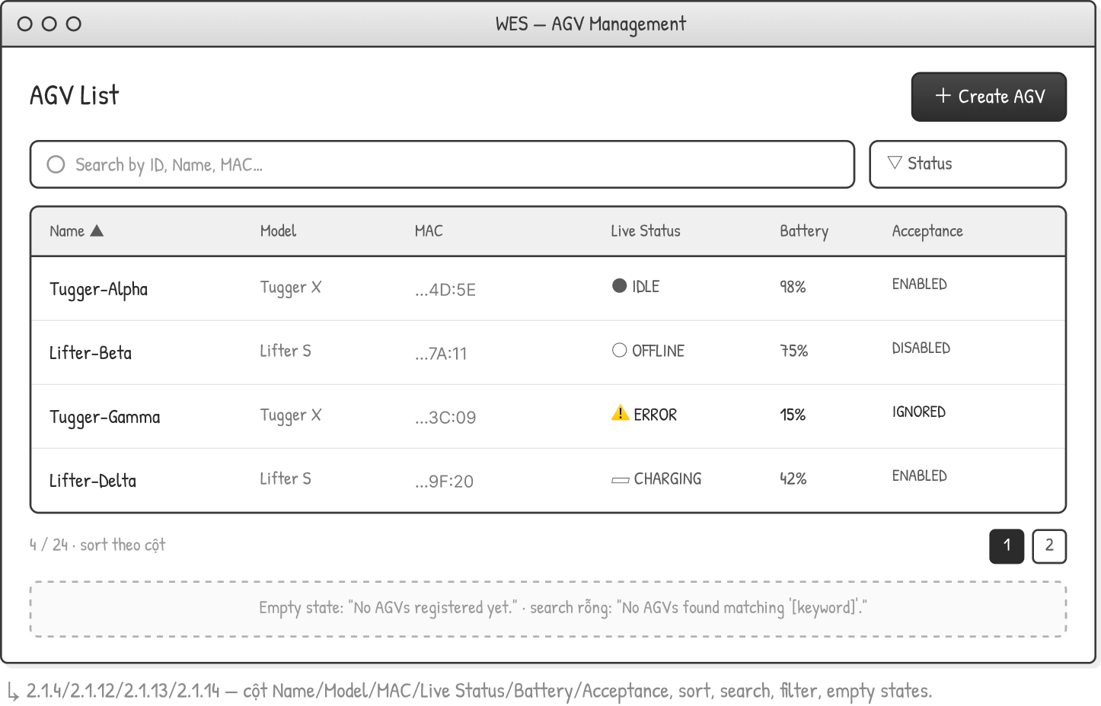
This screen allows the Administrator to:
• View AGV List: view all registered AGVs with the columns Name, Model, MAC, Live Status, Battery and Acceptance.
• Search AGV: enter keyword(s) to search AGVs by ID, Name or MAC address.
• Filter AGV: filter the list by Live Status (All, Idle/Online, Offline, Charging, Error).
• Sort AGV List: sort the list (ascending/descending) by clicking the column headers.
• Create AGV: open the Create AGV screen via the "+ Create AGV" button, or open AGV Detail by selecting a row.
Field Description
Field Name | Description
Search box | Free-text input; searches by ID, Name or AGV code; placeholder "Search by ID, Name, Code...".
Status filter | Dropdown; values: All, IDLE, EXECUTING, CHARGING, ERROR, UNAVAILABLE, UNKNOWN; default "All".
Name | AGV display name; sortable column.
Model | AGV model (e.g., Tugger X, Lifter S).
Code | Unique AGV code used to identify the vehicle.
Live Status | Real-time status reported by the kernel: IDLE, EXECUTING, CHARGING, ERROR, UNAVAILABLE or UNKNOWN.
Battery | Current battery level (%).
Acceptance | Dispatch acceptance state: ENABLED, DISABLED or IGNORED.
Empty state | "No AGVs registered yet."; when search has no result: "No AGVs found matching '[keyword]'."

3.1.2 Create AGV
Related use case(s):
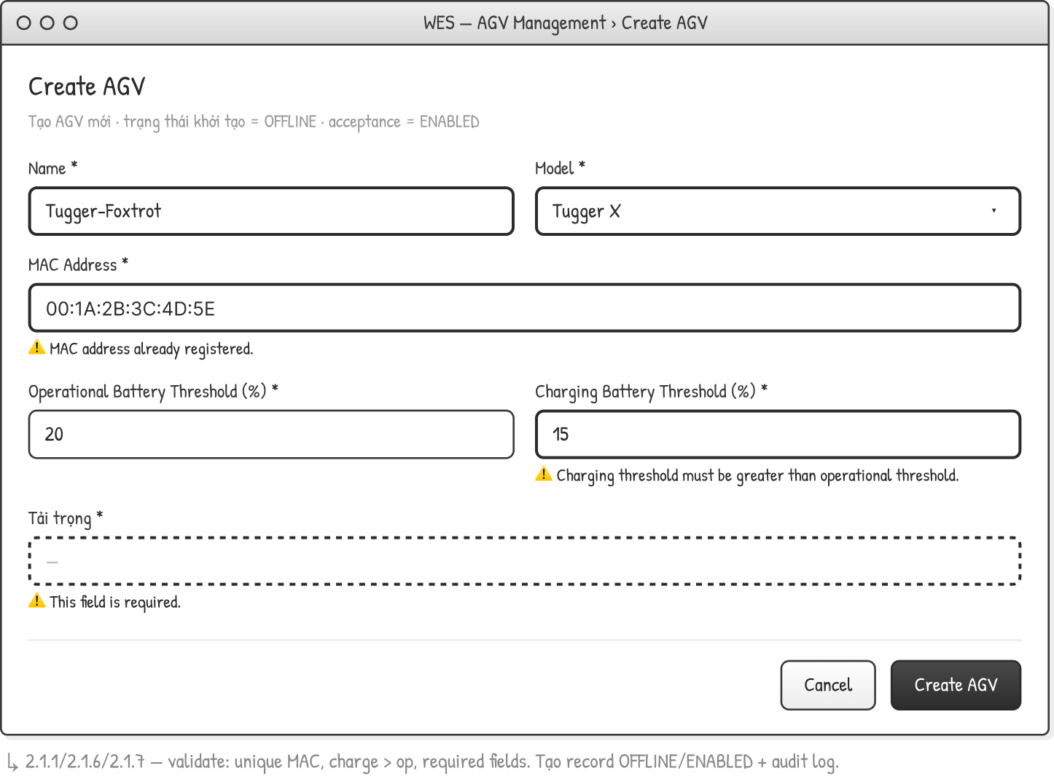
This screen allows the Administrator to:
• Add New AGV: create a new AGV record; initial Live Status = OFFLINE and Acceptance = ENABLED.
• Edit AGV: update an existing AGV's attributes.
• On save, the system validates the input (unique MAC, sufficient threshold greater than critical threshold, required fields), creates/updates the record and writes an audit log entry.
Field Description
Field Name | Description
Name | Required; AGV display name.
Model | Required; dropdown (Tugger X, Lifter S, ...).
Code | Required; must be unique; error "This AGV code is already registered."
Critical Battery Threshold (%) | Required; integer percentage.
Sufficient Battery Threshold (%) | Required; must be greater than the critical threshold; error "Sufficient threshold must be greater than the critical threshold."
Payload (Tai trong) | Required; numeric; error "This field is required." when empty.
Cancel / Create AGV | Buttons to discard or save the form.

3.1.3 AGV Detail & Status Control
Related use case(s):
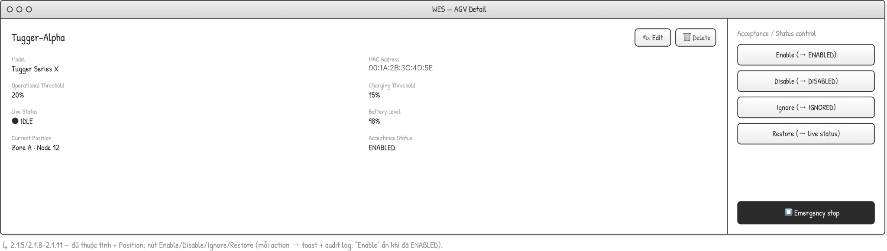
This screen allows the Administrator to:
• View AGV Detail: view full attributes (Model, MAC, thresholds, Live Status, Battery, Current Position, Acceptance).
• Control Acceptance/Status: Enable (-> ENABLED), Disable (-> DISABLED), Ignore (-> IGNORED), Restore (-> live status).
• Trigger an Emergency Stop on the AGV.
• Edit or Delete the AGV. Each status action shows a toast and writes an audit log; "Enable" is hidden when already ENABLED. The related confirmation dialogs and block/warning messages are described in 3.1.4.
Field Description
Field Name | Description
Model | Read-only attribute.
Code | Read-only attribute.
Critical Threshold | Critical battery threshold (%).
Sufficient Threshold | Sufficient battery threshold (%).
Live Status | IDLE / EXECUTING / CHARGING / ERROR / UNAVAILABLE / UNKNOWN.
Battery Level | Current battery level (%).
Current Position | Current location (Zone . Node).
Acceptance Status | ENABLED / DISABLED / IGNORED.
Enable / Disable / Ignore / Restore | Status-control buttons; each transition triggers a toast + audit log.
Emergency stop | Button to immediately stop the AGV.

3.1.4 AGV - Confirmations & Blocks
Related use case(s):
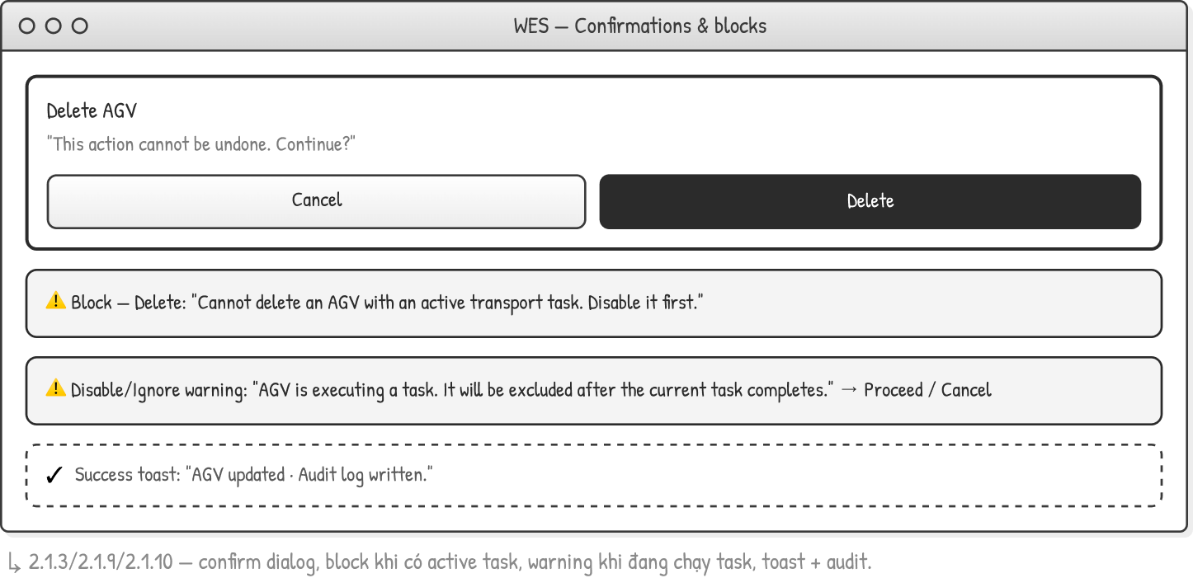
This screen allows the Administrator to:
• Confirm Delete: a confirmation dialog "This action cannot be undone. Continue?" with Cancel / Delete buttons.
• See a Block message when deletion is not allowed: "Cannot delete an AGV with an active transport task. Disable it first."
• See a Warning when disabling/ignoring a busy AGV: "AGV is executing a task. It will be excluded after the current task completes." (Proceed / Cancel).
• See a Success toast after an action: "AGV updated . Audit log written."
Field Description
Field Name | Description
Delete confirmation dialog | Message "This action cannot be undone. Continue?"; buttons Cancel / Delete.
Block - Delete | Blocking message when the AGV has an active transport task: "Cannot delete an AGV with an active transport task. Disable it first."
Disable/Ignore warning | Warning when the AGV is executing a task: "AGV is executing a task. It will be excluded after the current task completes."; buttons Proceed / Cancel.
Success toast | Confirmation feedback after a successful action: "AGV updated . Audit log written."

3.1.5 AGV Operation & Error History
Related use case(s):
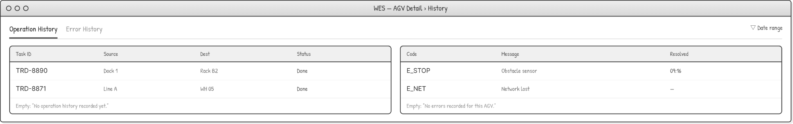
This screen allows the Administrator to:
• View Operation History: list executed/completed tasks (Task ID, Source, Destination, Start, End, Status).
• View Error History: list errors recorded for the AGV (Code, Message, Timestamp, Resolved).
• Filter the history by date range.
Field Description
Field Name | Description
Operation History / Error History | Tabs to switch between the two history views.
Date range | Filter to limit records by date.
Task ID / Source / Dest / Status | Operation history columns; empty state "No operation history recorded yet."
Code / Message / Resolved | Error history columns; empty state "No errors recorded for this AGV."

3.2 Warehouse Map & Topology

3.2.1 Upload / Replace Operation Map
Related use case(s):
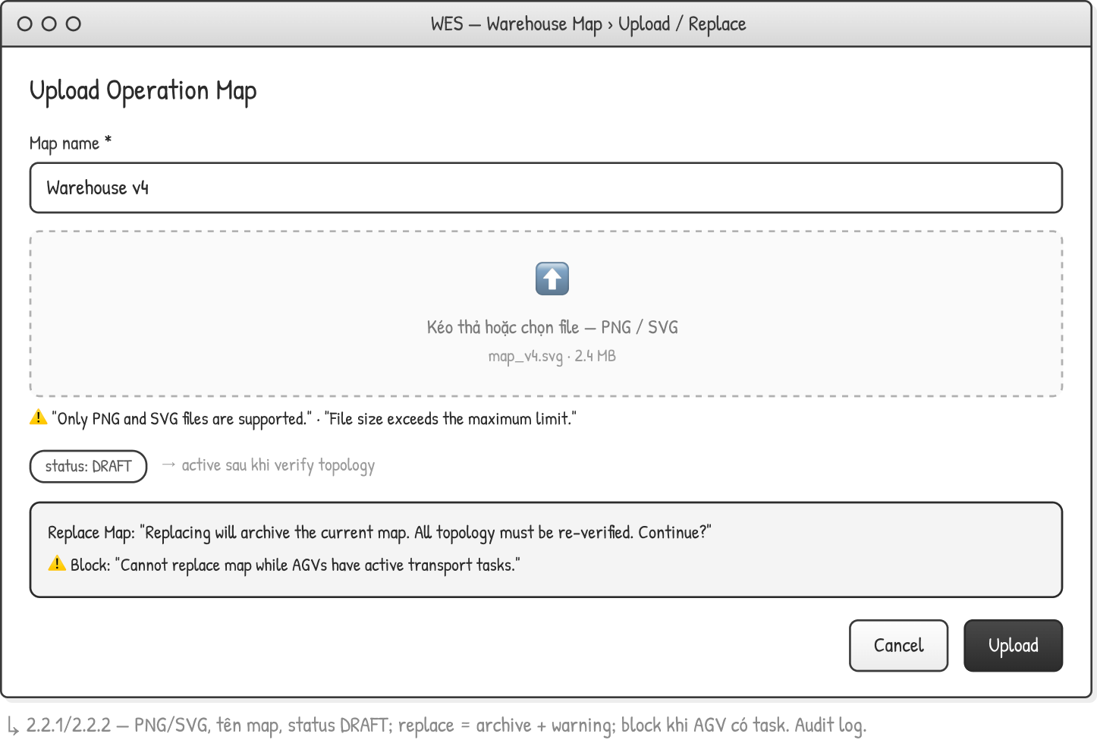
This screen allows the Administrator to:
• Upload Operation Map: upload a new map (PNG/SVG) with a map name; the new map status = DRAFT and becomes active after the topology is verified.
• Replace Map: replace the current map; the current map is archived and all topology must be re-verified.
• The system validates the file type and size; Replace is blocked while AGVs have active transport tasks. An audit log entry is written.
Field Description
Field Name | Description
Map name | Required; text.
Map file | PNG/SVG; drag-drop or pick; errors "Only PNG and SVG files are supported." / "File size exceeds the maximum limit."
Status | DRAFT -> active after topology verification.
Cancel / Upload | Buttons to discard or upload the map.

3.2.4 Operational Location Management
Related use case(s):
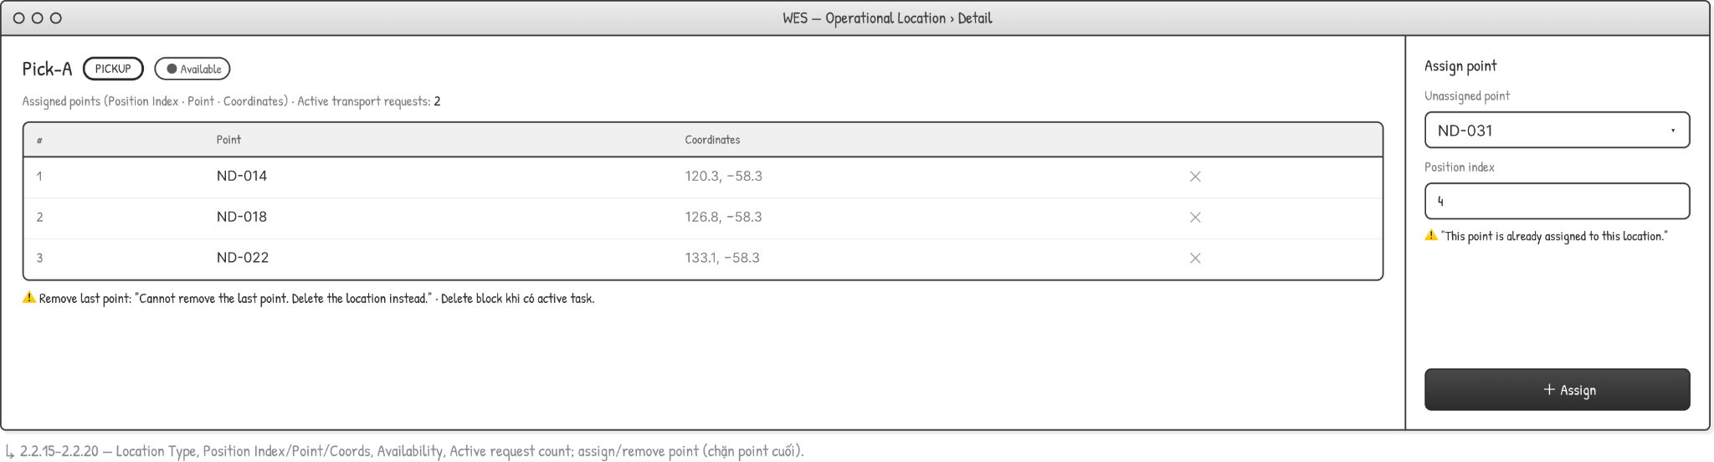
This screen allows the Administrator to:
• Create / Edit / Delete / View an operational location with its Type and assigned points (Position Index, Point, Coordinates).
• View Availability and the number of active transport requests referencing the location.
• Assign or remove points; the last point cannot be removed (delete the location instead); deletion is blocked when there is an active task.
Field Description
Field Name | Description
Name | Location name.
Type | PICKUP / DROPOFF / CHARGE / PARKING.
Availability | Available / occupied status.
Assigned points | List of Position Index . Point . Coordinates.
Active transport requests | Count of active requests referencing the location.
Assign point | Unassigned point + position index; error "This point is already assigned to this location."

3.3 User & Access Management

3.3.1 Login
Related use case(s):
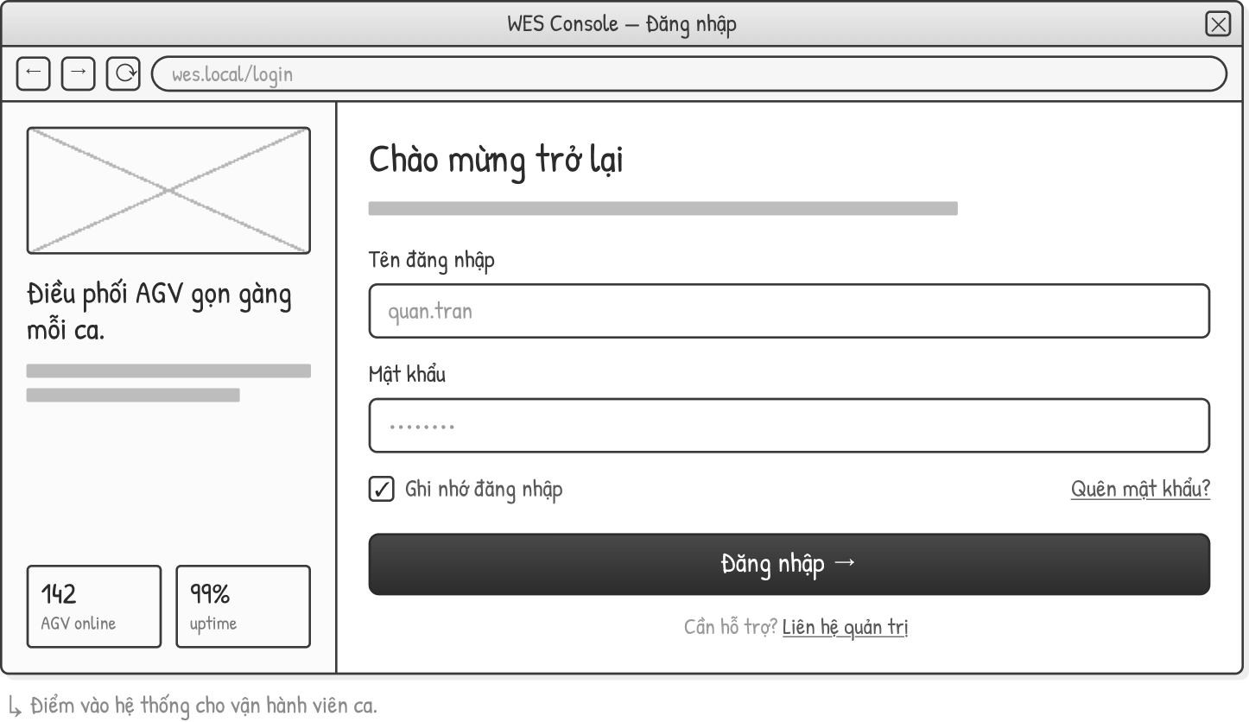
This screen allows the user (Operator / Administrator) to:
• Login: authenticate with username and password to enter the system.
• Choose "Remember me" to keep the session.
• Navigate to the password-recovery flow via the "Forgot password?" link.
Field Description
Field Name | Description
Username | Required; text.
Password | Required; masked input.
Remember me | Checkbox to remember the login.
Login | Submit button.
Forgot password? | Link to the Forgot Password screen.

3.3.2 Forgot Password
Related use case(s):
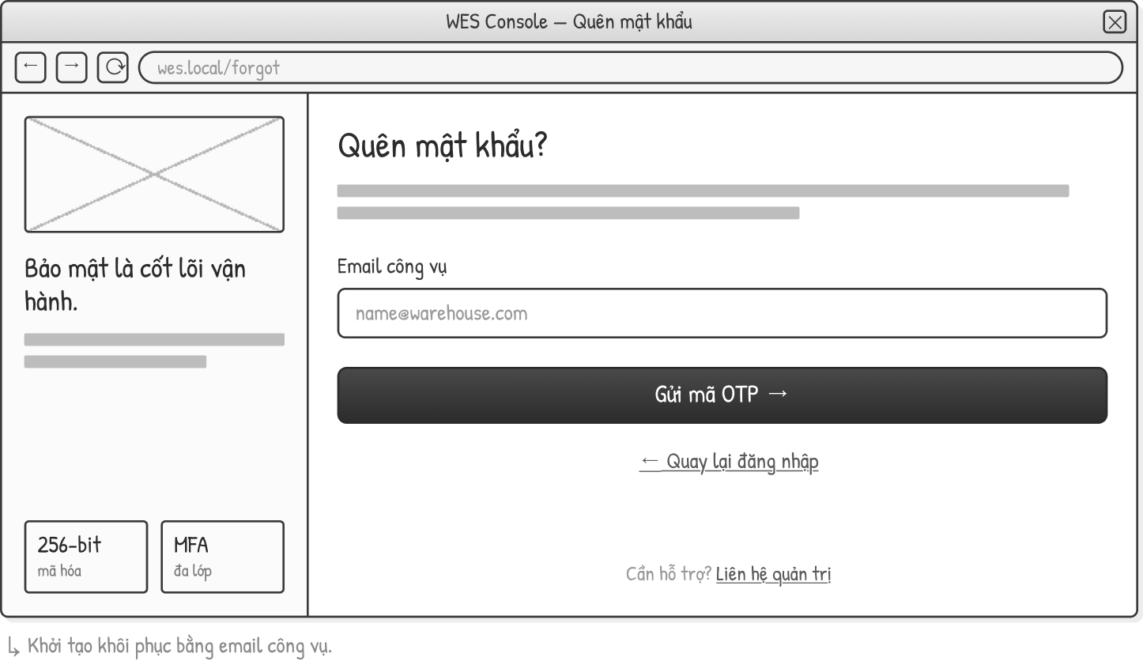
This screen allows the user (Operator / Administrator) to:
• Request OTP: initiate password recovery by entering the corporate email; the system sends a one-time code (OTP).
• Return to the Login screen.
Field Description
Field Name | Description
Email (corporate) | Required; corporate email; placeholder "name@warehouse.com".
Send OTP | Submit button to send the one-time code.
Back to login | Link to return to the Login screen.

3.3.3 Reset Password
Related use case(s):
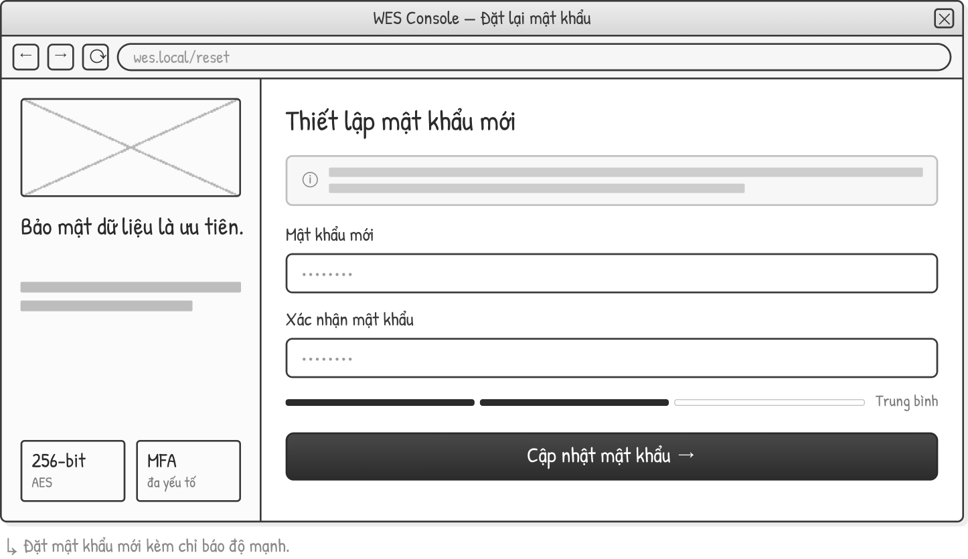
This screen allows the user (Operator / Administrator) to:
• Set a new password and confirm it; a password-strength indicator is shown.
Field Description
Field Name | Description
New password | Required; masked; a password-strength indicator is shown.
Confirm password | Required; masked; must match the new password.
Update password | Submit button to apply the new password.

3.3.4 Account - Profile
Related use case(s):
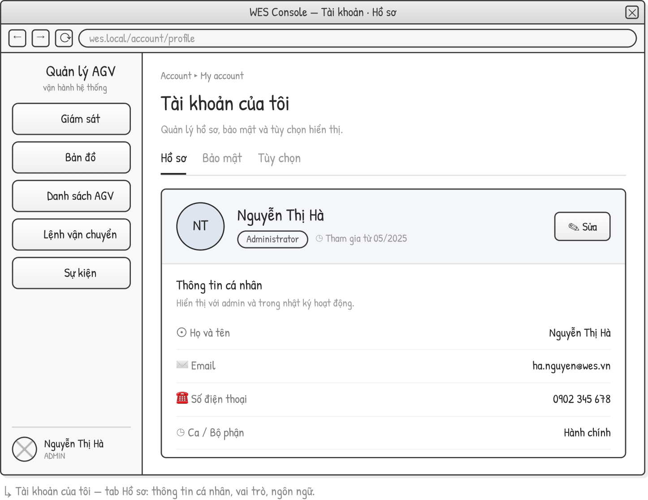
This screen allows the authenticated user to:
• View Profile: view personal information (Full name, Email, Phone, Shift/Department, Role, Interface language) across the Profile / Security / Preferences tabs.
• Choose Edit to switch to the edit mode (see 3.3.6).
Field Description
Field Name | Description
Full name / Email / Phone / Shift-Department | Read-only personal information.
Role | Read-only; set by the administrator.
Interface language | Display language (e.g., English / Vietnamese).
Edit | Button to switch to the edit mode.

3.3.5 Account - Edit Profile
Related use case(s):
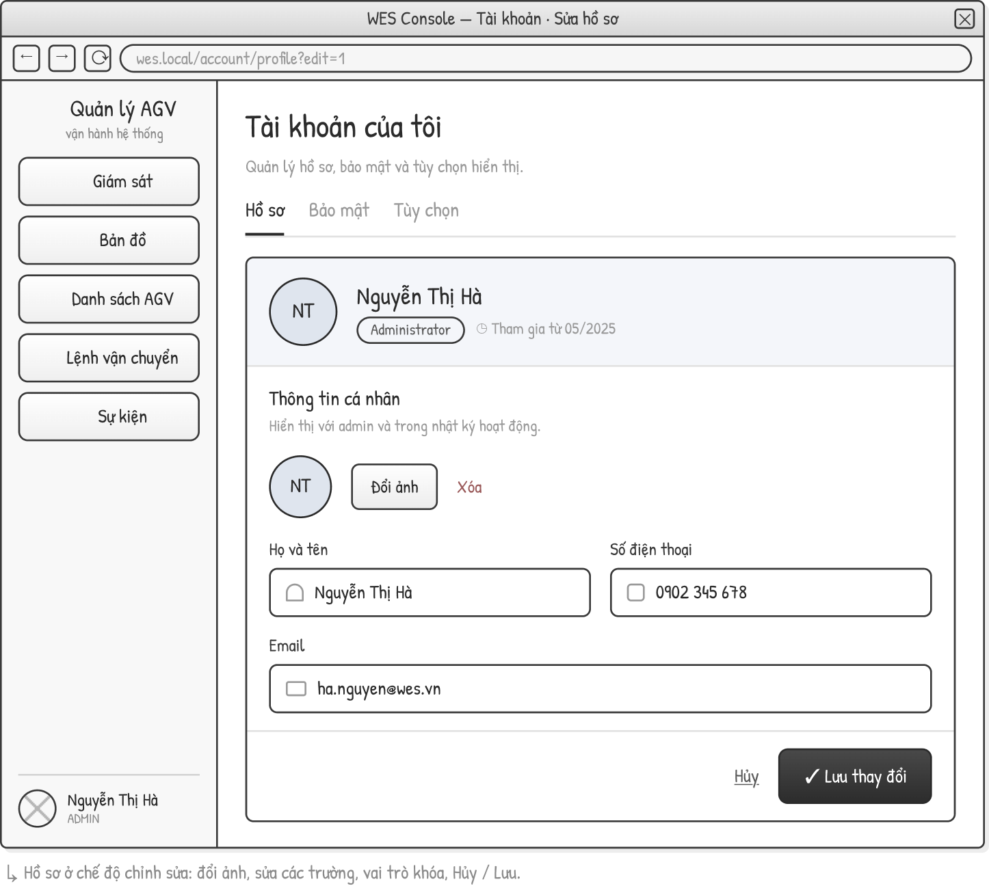
This screen allows the authenticated user to:
• Edit Profile: edit personal information and change or remove the avatar.
• Save or cancel the changes; the Role field is read-only (set by the administrator).
Field Description
Field Name | Description
Avatar | Change / remove profile photo.
Full name / Phone / Email / Shift-Department | Editable fields.
Role | Read-only; set by the administrator.
Cancel / Save changes | Buttons to discard or save the changes.

3.3.6 Account - change password
Related use case(s):
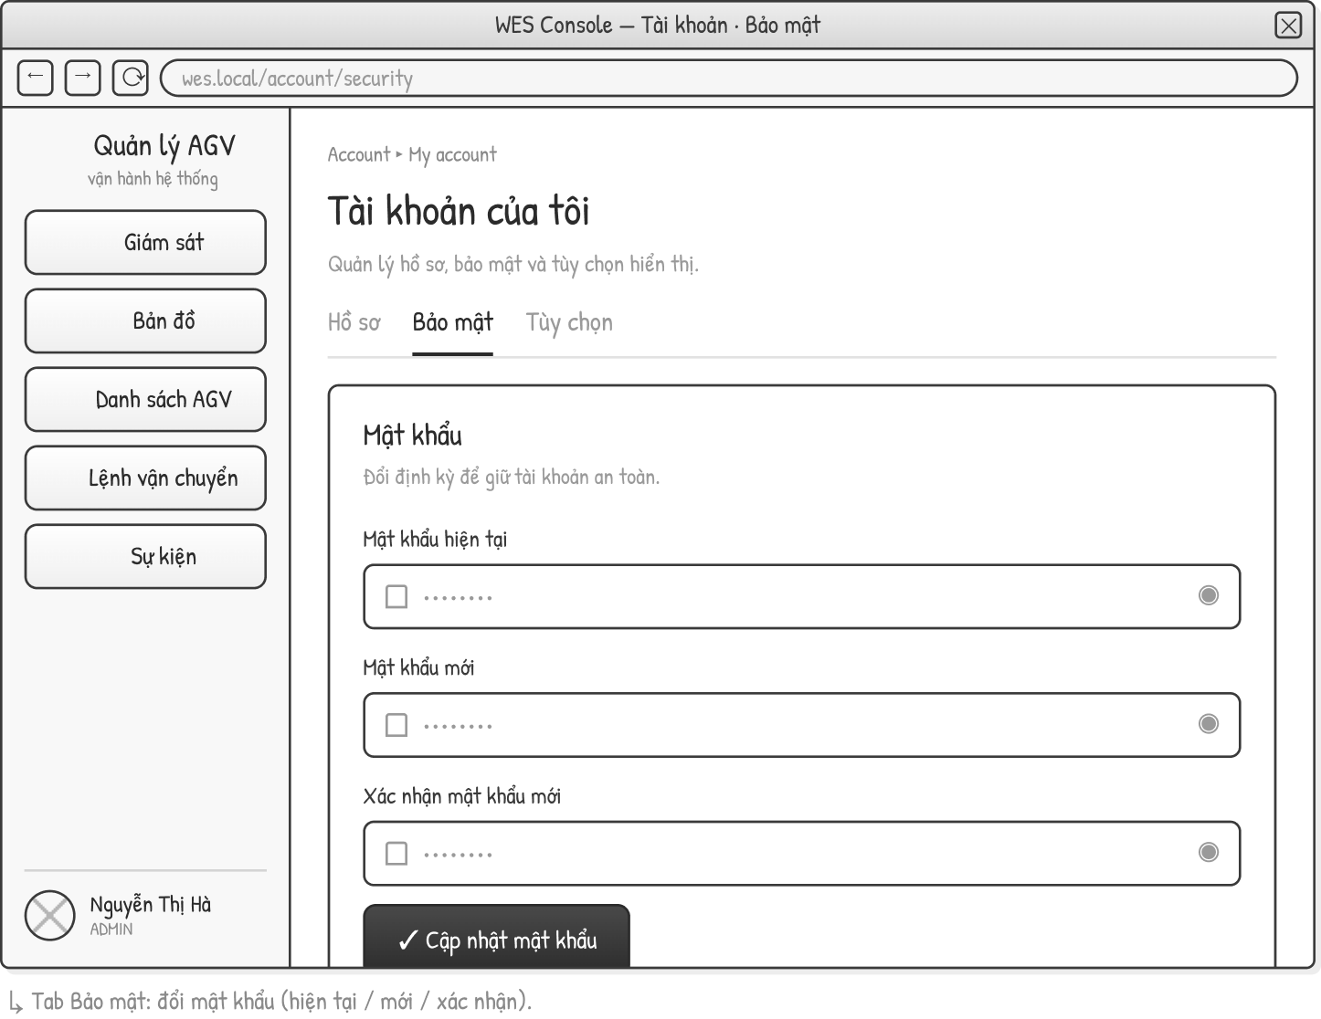
This screen allows the authenticated user to:
• Change Password: change own password by entering the current, new and confirmation passwords.
Field Description
Field Name | Description
Current password | Required; masked.
New password | Required; masked.
Confirm new password | Required; masked; must match the new password.
Update password | Submit button to apply the new password.

3.3.7 Create User
Related use case(s):
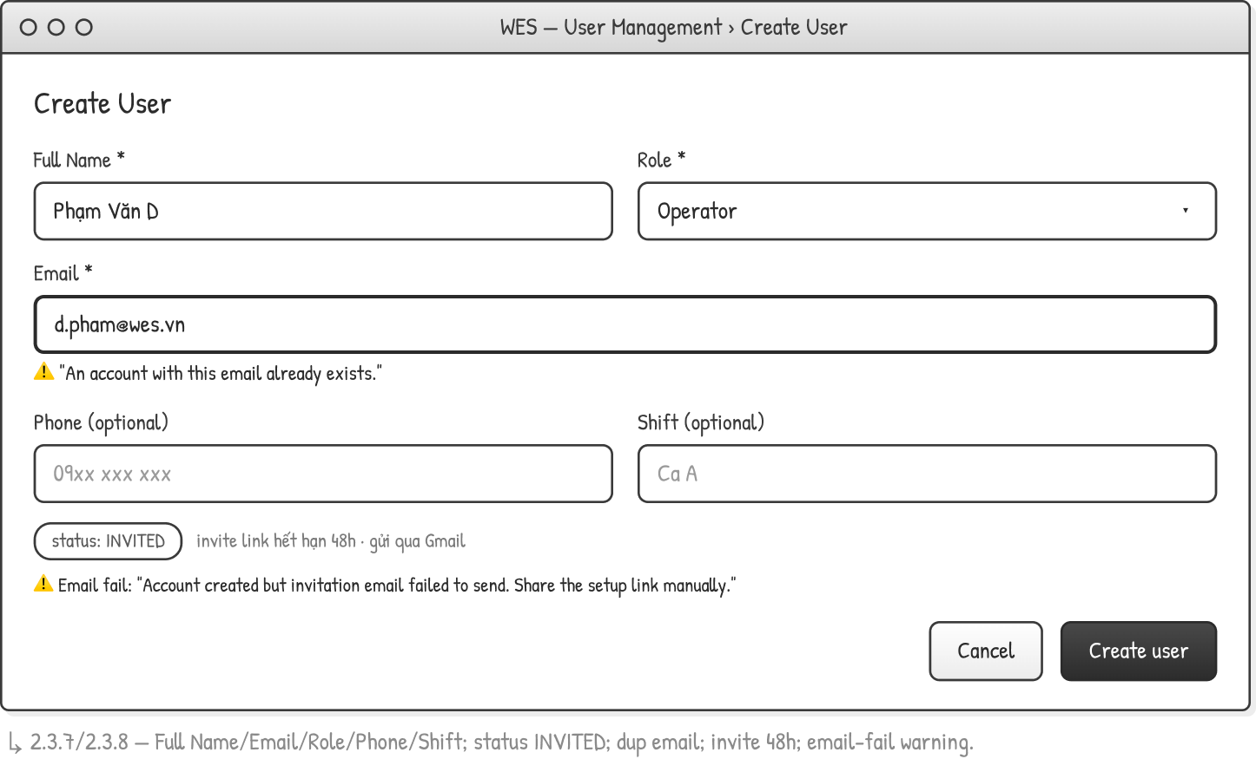
This screen allows the Administrator to:
• Create User: create an account with Full name, Email, Role and optional Phone and Shift; the account status = INVITED.
• An invitation link is sent by email and expires after 48 hours.
• The system validates a unique email; on email failure it shows "Account created but invitation email failed to send. Share the setup link manually."
Field Description
Field Name | Description
Full Name | Required.
Role | Required; dropdown (Operator, Admin, Viewer).
Email | Required; unique; error "An account with this email already exists."
Phone | Optional.
Shift | Optional.

3.3.8 User List & Detail
Related use case(s):
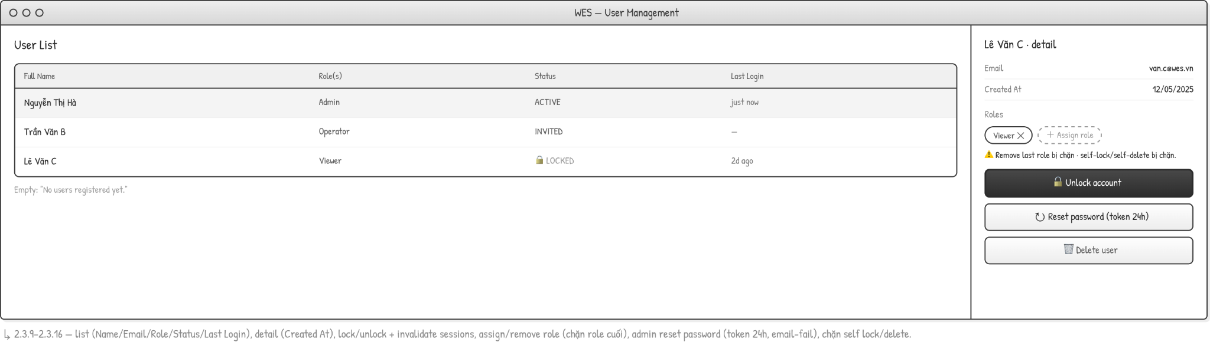
This screen allows the Administrator to:
• View User List: columns Full Name, Role(s), Status, Last Login; empty state "No users registered yet."
• View User Detail: Email, Created At and assigned Roles.
• Assign or remove a role (the last role cannot be removed).
• Lock / Unlock an account (unlocking invalidates active sessions) and Admin-reset the password (reset token valid for 24 hours).
• Delete a user. Self-lock and self-delete are blocked.
Field Description
Field Name | Description
Full Name | User display name (column).
Role(s) | Assigned role(s).
Status | ACTIVE / INVITED / LOCKED.
Last Login | Last login timestamp.
Created At | Account creation date (detail).
Assign role / Remove role | Role management; at least one role required.
Unlock account / Reset password / Delete user | Access-control actions (lock/unlock invalidates sessions; reset token 24h).

4. Non-Functional Requirements

4.1 External Interfaces

# | Interface | Direction | Protocol | Description
1 | FMS (openTCS) | WES -> FMS | REST/HTTP | WES sends the Transport Order with an already assigned intendedVehicle. FMS does not select the vehicle itself — it only executes the routing and controls the AGV hardware.
2 | FMS (openTCS) | FMS -> WES | REST Callback / Polling | FMS pushes telemetry data (AGV position, battery, status) and task state transitions (DELIVERING, DELIVERY_COMPLETED, FAILED, WITHDRAWAL_CONFIRMED) back to WES.
3 | Barcode Scanner / Handheld App | Scanner -> WES | REST/HTTP | The scanning client calls the WES API endpoint to create a Cargo entity and initiate a Transport Request. The payload includes: source QR point, destination barcode, and cargo metadata.
4 | Gmail Service | WES -> Gmail | SMTP / Gmail OAuth2 | WES sends emails via the Gmail API for the following events: password reset links (TTL = RESET_TTL_MINUTES, default 30 minutes), new account invitation links, and admin-triggered password reset links.

4.2 Quality Attributes

4.2.1 Usability
Operators must require no more than 30 minutes of training to perform daily operations: creating Transport Requests, tracking task statuses, and viewing the Dashboard.
Admins must require no more than 2 hours of training to configure the Map, AGV fleet, Dispatch Policy, and manage users.
All destructive actions (Delete AGV, Cancel Request, Delete Cargo, Lock User, Replace Map) must display a confirmation dialog before execution.
The system must display clear error messages (following the System Messages table in Section 5.2) when validation fails — displaying blank prompts or raw exceptions is strictly prohibited.
The UI must function properly on screen resolutions of 1280×720 and above using Google Chrome.

4.2.2 Performance

Metric | Target
AGV live status sync (battery, position, state) | ≤ 2 seconds
API response time — read requests (list, detail) | ≤ 1 second under normal conditions
Dispatch engine: from request entering the queue to AGV assignment and sending to FMS | ≤ 5 seconds
Dashboard KPI widgets load time | ≤ 3 seconds
SSE push latency (AGV position update to browser) | ≤ 1 second
Minimum concurrent AGVs | 20 AGVs
Minimum concurrent Transport Requests | 50 requests

4.2.3 Security

Requirement | Details
Authentication | JWT Access Token, TTL = JWT_ACCESS_TTL env var (default 15m). Signed with JWT_SECRET. Sent via Authorization: Bearer header. Payload: { sub: userId, username, roles: [role] }.
Refresh Token | TTL = REFRESH_TTL_DAYS env var (default 7 days). Stored as an SHA-256 hash in the refresh_tokens table — plain text storage is strictly prohibited. Rotation: upon each /auth/refresh request, the old token is revoked and a new token is issued. Sent via an httpOnly cookie named wes_refresh (path: /api/auth, sameSite: lax).
Password Hashing | bcrypt, BCRYPT_ROUNDS = 10.
Password Reset | The token is a reset link (not an OTP code). TTL = RESET_TTL_MINUTES env var (default 30 minutes). Stored as an SHA-256 hash, single-use (marked with usedAt upon usage). Automatically invalidated immediately after use or expiration.
Account Enumeration Protection | forgotPassword() must always return { ok: true } regardless of whether the email exists in the system, ensuring account information is not leaked.
Authorization | Role-based: ADMIN / OPERATOR. Enforced via RolesGuard + @Roles() decorator on each endpoint. Unauthorized access must return an HTTP 403 ForbiddenException.
Account States | Uses 3 flags: isLocked (manually locked by Admin), isActive (active account), isInvited (created by Admin but password not yet set). Accounts with isInvited = true are restricted from logging in until the invitation flow is completed.
Session Invalidation | Logout triggers endAllSessions() (marks logoutAt for all active sessions of the user). Resetting a password triggers revokeAllRefreshTokens() (revokes all refresh tokens, forcing re-login across all devices).
Session Logging | Every login is recorded in the user_sessions table, capturing: IP address, User-Agent, and loginAt. Logout actions record the logoutAt timestamp.

4.2.4 Reliability

Requirement | Details
Dispatch engine uptime | ≥ 99.5% during warehouse operational hours.
FMS sync interruption | WES displays "Last synced at [timestamp]" and does not crash. Operations independent of the FMS still function normally.
FMS withdrawal failure | WES retries using an exponential backoff policy (up to 3 times). If it still fails $\rightarrow$ writes an Event Log entry and notifies the Admin for manual handling. The task maintains the CANCELLING state until confirmed by the FMS.
Audit completeness | Every Create / Update / Delete operation on main entities must write an Audit Log entry before returning a successful response to the client.

4.2.5 Compatibility

Category | Requirement
Browser | Google Chrome (modern versions)
Screen resolution | Minimum 1280×720. Mobile responsive is not required.
Database | PostgreSQL
FMS | openTCS (custom fork — according to the integration contract agreed with the FMS team)

5. Requirement Appendix

5.1 Business Rules
ID | Rule Definition
BR-01 | criticalBatteryThreshold must always be lower than sufficientBatteryThreshold. The system blocks saving if this condition is violated. An AGV is forced to charge when its battery falls to or below the critical threshold, and is considered sufficiently charged (eligible for release from charging) at or above the sufficient threshold.
BR-02 | An AGV is only included in the candidate set for assignment if batteryLevel > criticalBatteryThreshold.
BR-03 | An AGV at or below the critical threshold finishes its current transport task, then charges; it takes no new work until released. It is released once its battery reaches or exceeds the sufficient threshold AND there is demand: (a) a pending transport request — it is dispatched to serve it; or (b) another AGV at or below the critical threshold needs the slot — it yields the charge point and moves to a parking position and is not given work. With no demand it keeps charging toward full; once fully charged it likewise leaves the charge point for a parking position. Every such parking position is one that is not part of a charge location (BR-15). If no charging station has a free slot, the AGV is parked and re-evaluated on the next dispatch cycle.
BR-04 | A Transport Request can only be assigned to a maximum of one AGV at a time.
BR-05 | An AGV can execute a maximum of one active Transport Request at a time.
BR-06 | An AGV with acceptance status = IGNORED is excluded from all dispatch logic, including the forced charging cycle. It nevertheless remains a spatial obstacle in fleet routing: exclusion applies to work allocation only, never to collision avoidance. A vehicle standing on the floor occupies its position regardless of its administrative status.
BR-07 | When creating Cargo: the source must be a Point with type = PICKUP; the destination must be a Location with type = DROPOFF. If not met $\rightarrow$ the creation is rejected with a reason (fail-fast); no Cargo or Transport Request is persisted.
BR-08 | Delete Cargo is only allowed if the linked Transport Request (if any) has not reached the DELIVERING or DELIVERY_COMPLETED state.
BR-09 | A Transport Request cannot be Cancelled if it is already in the DELIVERY_COMPLETED or CANCELLED state. These are terminal states of the task lifecycle.
BR-10 | Pickup zone — Outer before Inner: An AGV is only allowed to pick up goods at a slot if all slots located between that slot and the zone entrance are in the EMPTY state. Applied at the Release Engine when evaluating dependencies before adding a task to the Candidate set.
BR-11 | Drop-off zone - Cascading Depth-First Fill: within a DROPOFF location the slots are filled farthest-from-exit first, cascading over hops-to-exit columns, so a later drop never sits between an earlier one and the zone exit. Applied by the Delivery Slot Engine when the concrete slot is committed at the approach barrier.
BR-12 | An operational location's member points may be added or removed, and the location itself may be deleted, only while no cargo references it: no active cargo may hold it as its source or destination zone. The check and the change run under the same per-zone lock as seat reservation. Name and colour may be changed at any time; the location type is fixed at creation.
BR-13 | A charging AGV is routed to the nearest CHARGE location that has a free slot; the slot is reserved under the same per-zone lock used for drop-off seat reservation.
BR-14 | Forced charging takes priority over idle parking. An AGV en route to a parking position that falls to or below the critical threshold is redirected to a charging station.
BR-15 | Idle parking targets a parking position that is not part of a charge location; charge points are reserved for charging. A charge point is used as a parking destination only when no non-charge parking position is reachable.

5.2 System Messages
# | Message code | Message Type | Context | Content
1 | MSG-01 | Inline | No search results | No results found.
2 | MSG-02 | Red inline, below field | Required field left blank | This field is required.
3 | MSG-03 | Toast success | Update successful | Updated successfully.
4 | MSG-04 | Toast success | Creation successful | Created successfully.
5 | MSG-05 | Toast success | Deletion successful | Deleted successfully.
6 | MSG-06 | Toast success | Email sent | Email sent to {email_address}.
7 | MSG-07 | Toast success | Reset / Restore successful | Reset successfully.
8 | MSG-08 | Red inline, below field | Entered value exceeds max length | Exceeds maximum length of {max_length} characters.
9 | MSG-09 | Inline | Incorrect credentials during login | Incorrect username or password.
10 | MSG-10 | Inline | Account locked by admin (isLocked = true) | Your account has been locked. Contact your administrator.
11 | MSG-11 | Inline | Account not activated (isInvited = true) | Your account has not been activated yet. Please check your invitation email.
12 | MSG-12 | Inline | Forgot password — do not reveal if email exists or not | If this email is registered, you will receive a reset link.
13 | MSG-13 | Inline | Reset token invalid or expired | Reset link is invalid or has expired. Please request a new one.
14 | MSG-14 | Red inline, below field | Duplicate AGV code when creating/editing AGV | This AGV code is already registered.
15 | MSG-15 | Red inline, below field | Battery threshold relationship violated | Critical threshold must be lower than the sufficient threshold.
16 | MSG-16 | Inline | Deleting AGV while it has an active task | Cannot delete an AGV with an active transport task. Disable it first.
17 | MSG-17 | Inline | Removing the last Point from a Location | Cannot remove the last point. Delete the location instead.
18 | MSG-18 | Red inline, below field | Duplicate email when creating user | An account with this email already exists.
19 | MSG-19 | Inline | Revoking the last role of a user | Cannot remove the last role. Assign another role first or delete the account.
20 | MSG-20 | Inline | Replacing Map while there are active tasks | Cannot replace the map while AGVs have active transport tasks.
23 | MSG-23 | Inline | Invalid cargo — source/dest not in active topology | Invalid cargo: source point or destination location not found in active topology.
24 | MSG-24 | Inline | Deleting Cargo after AGV is DELIVERING | Cannot delete cargo: the AGV has already picked up this item. Wait for delivery to complete.
25 | MSG-25 | Toast warning | Account created successfully but invitation email failed to send | Account created but invitation email failed to send. Share the setup link manually.
26 | MSG-26 | Inline | Cancelling a request that is already COMPLETED or CANCELLED | Cannot cancel a request that is already completed or cancelled.
27 | MSG-27 | Toast warning | Disabling an AGV that has an active task | AGV has an active task. It will stop accepting new assignments after the current task completes.

5.3 Other Requirements

# | Requirement | Details
1 | OR-01 | Data Retention — Event Log: Event Log and AGV Error History are retained for a minimum of 90 days. Afterward, they can be archived or purged according to Admin policy.
2 | OR-02 | Data Retention — Audit Log: Audit Logs (AGV/Map/Dispatch/User changes) are retained for a minimum of 180 days due to traceability requirements.
3 | OR-03 | Data Retention — KPI Snapshot: KPI Snapshots are retained for a minimum of 365 days to support long-term trend analysis.
4 | OR-04 | Localization: The default UI language is English. Language preference is stored per-user in the UserPreference table.
5 | OR-05 | Audit Completeness: Every Create / Update / Delete operation on entities: AGV, OperationMap, Point, Path, Location, Block, DispatchPolicy, User, UserRole must create an AuditLog record containing: entity type, entity ID, action type, changed fields (before/after), actor user ID, and timestamp.
6 | OR-06 | Integration Contract — FMS: WES sends the Transport Order to the FMS with the intendedVehicle field mandated. The FMS does not select the vehicle itself. WES is not responsible for pathfinding — that is the responsibility of the FMS (openTCS MAPF).
7 | OR-07 | Debounce Window: After new cargo is created, WES waits for 1.5 seconds (debounce) before triggering the conflict check and dispatch cycle. The window resets each time additional cargo is added within the same batch.
8 | OR-08 | Export: Admin can export the Event Log to CSV or PDF, filtered by date range and module.

